REVIEW 3 – GROUP II – 23- APR – 2019

1. **SITE MAP**
2. **Client’s site map**

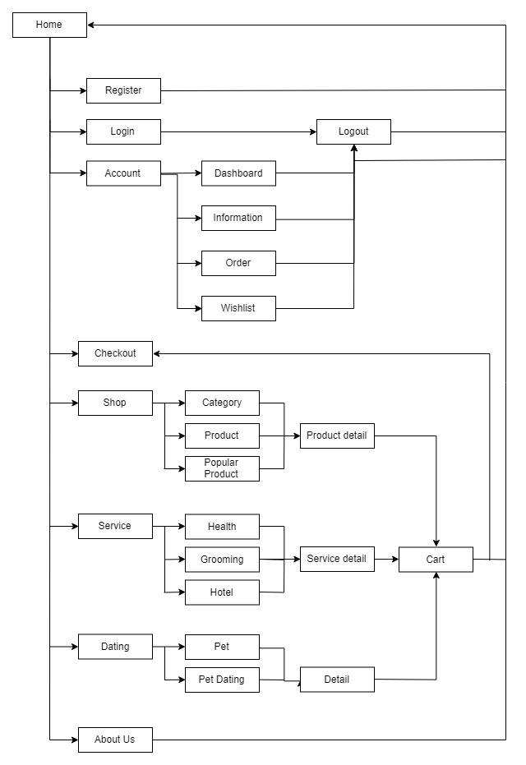

1. **Admin’s site map**
2. **GUI DESIGN**
3. **Client’s side**
   * 1. ***Home***

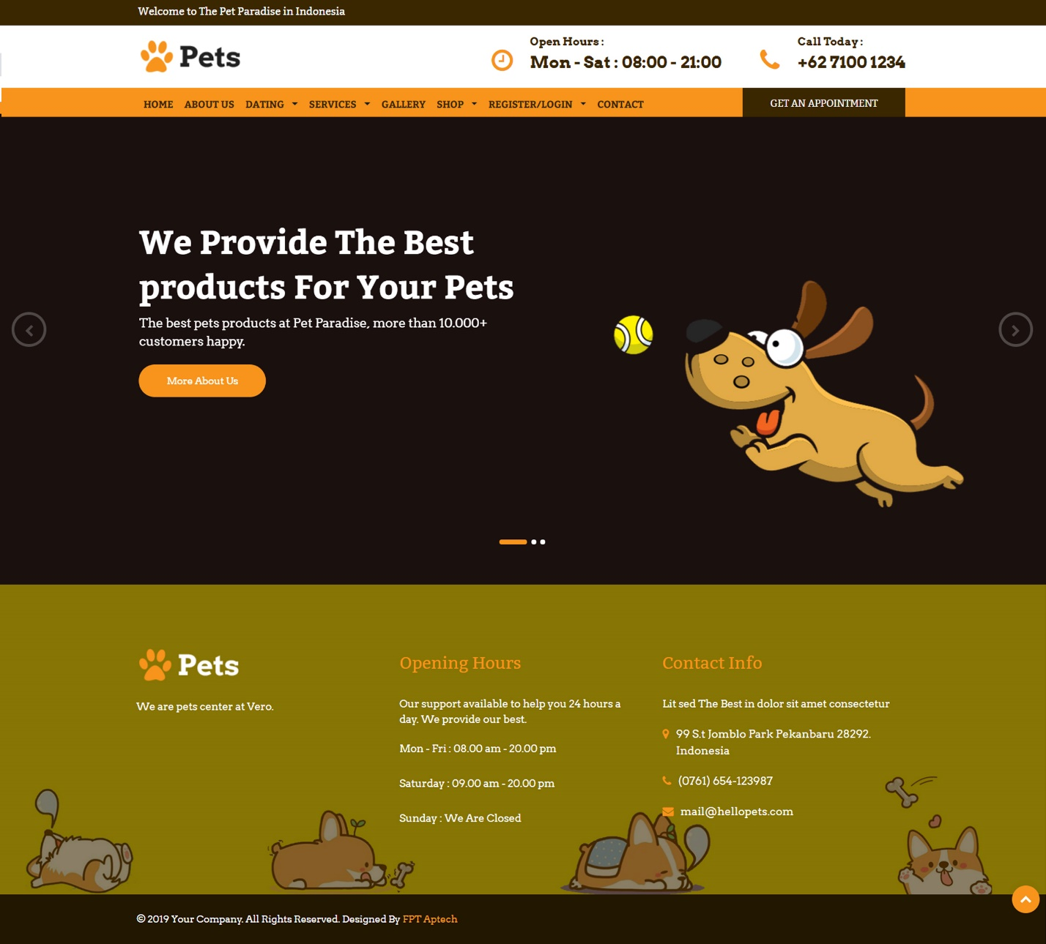

|  |  |
| --- | --- |
| Description | Home page |
| Connect From | N/A |
| Connect To | Login page, Sign Up, Product page, Shop, Services, Gallery.. |
| Validation | N/A |
| Initial Values | N/A |
| Events | - Navigate the website by clicking on menu Shop, Service, .. |

* + 1. ***Register***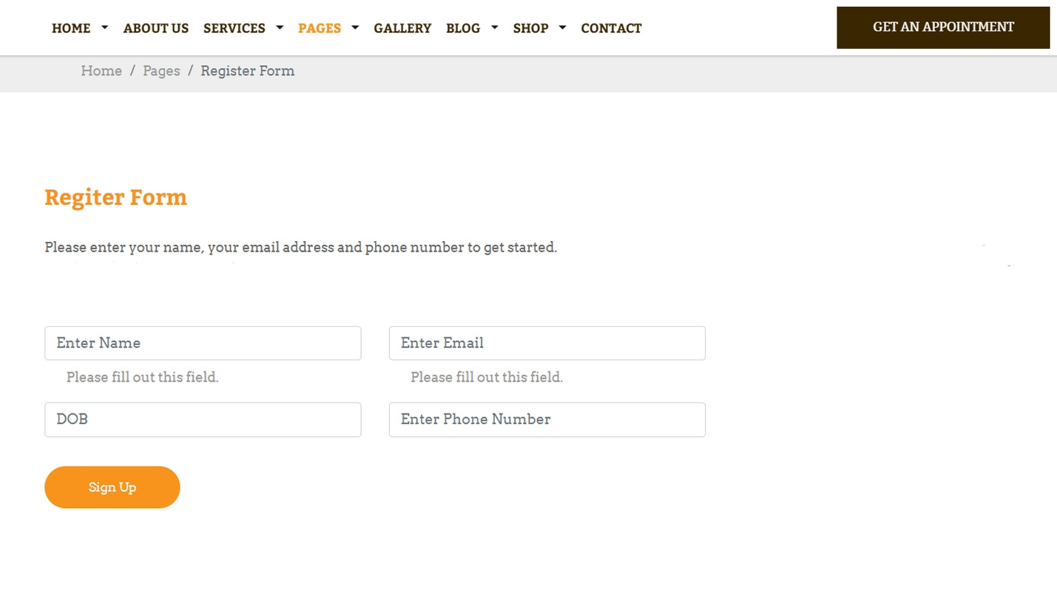

|  |  |
| --- | --- |
| Description | Guest signs up for new account |
| Connect From | Home |
| Connect To | Login page, Home |
| Validation | - All fields: not blank  - Name: must be not contains special characters  - Email: must be valid email format  - Password: must be between 6 to 20 characters - Phone Number: must be unique, valid phone number |
| Initial Values | N/A |
| Events | - When click button "Sign Up", check phone and password. If success, go to login page |

* + 1. ***Login***

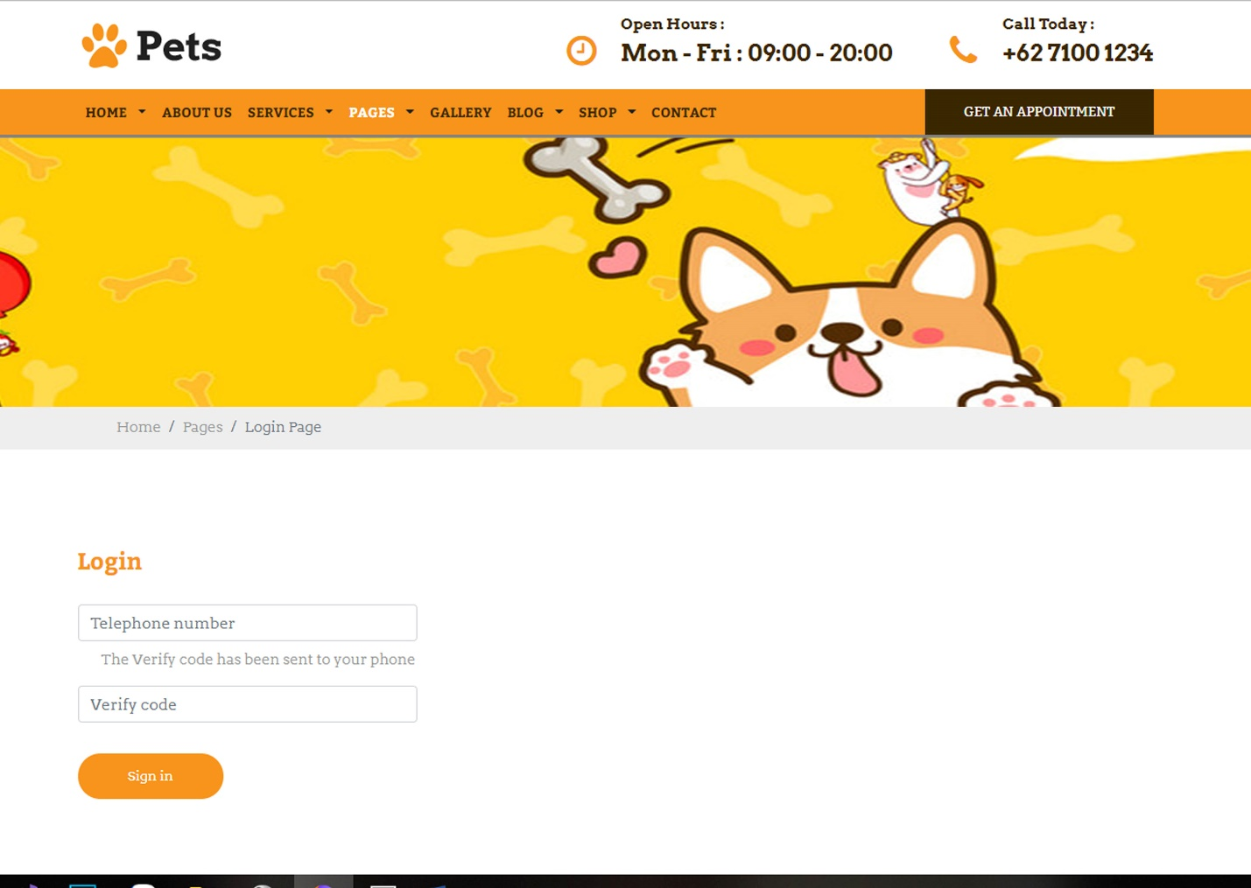

|  |  |
| --- | --- |
| Description | Login with Phone Number and Verify code |
| Connect From | Home |
| Connect To | Customer’s profile |
| Validation | All fields: not blank - Phone: must be valid phone number format - Verify: from SMS |
| Initial Values | N/A |
| Events | - When click button "Sign In", check phone number, then login. Login success, go to profile page |

* + 1. ***Dating list***

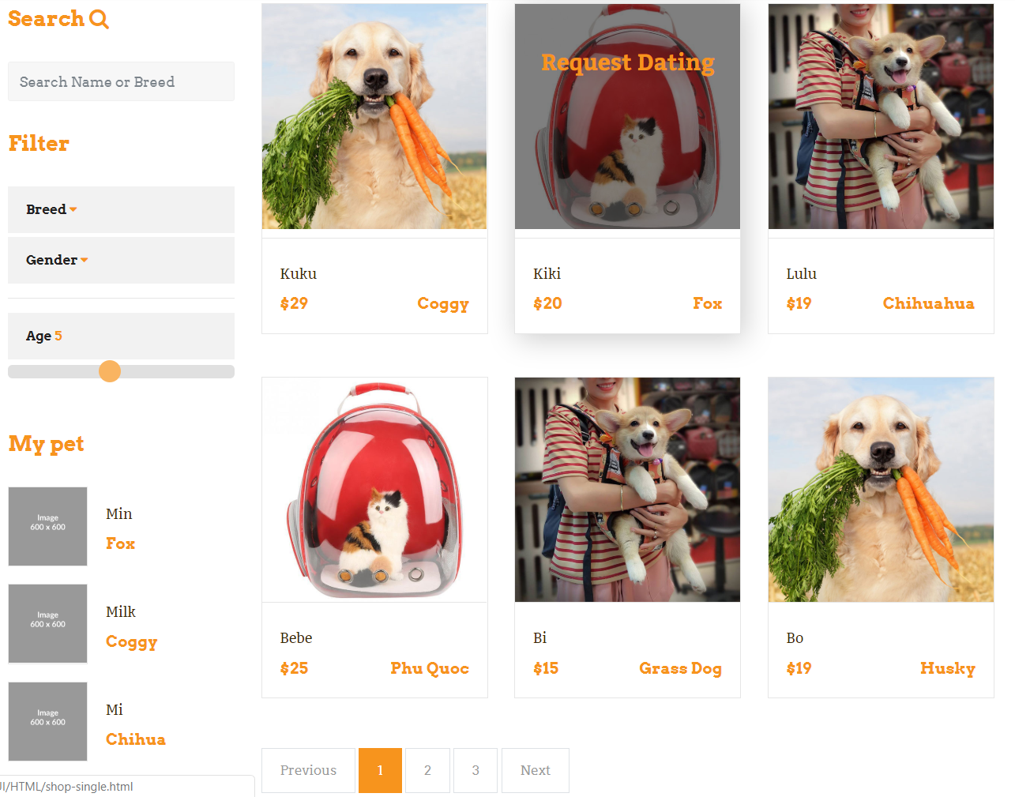

|  |  |
| --- | --- |
| Description | Show list of Pet list, filter (breed, gender or age) and my pet, search (name, breed) |
| Connect From | Home |
| Connect To | Pet dating, Pet detail |
| Validation | N/A |
| Initial Values | List of pet dating |
| Events | - When click on pet dating, redirect to pet dating detail  - When click on my Pet, redirect to pet detail  - When click on gallery item, redirect to gallery detail |

* + 1. ***Pet Dating***

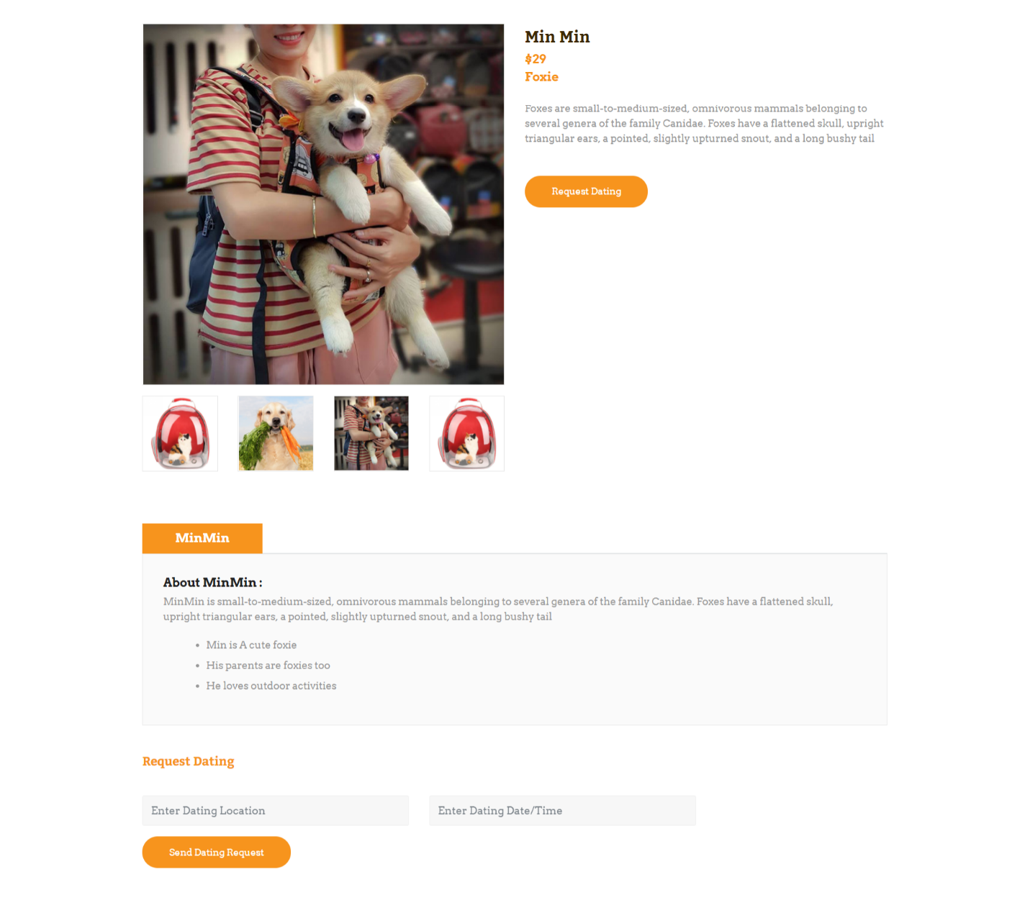

|  |  |
| --- | --- |
| Description | Show the detail of pet which want to date |
| Connect From | Home |
| Connect To | Request dating |
| Validation | N/A |
| Initial Values | N/A |
| Events | - When click on ‘Send Dating Request, will send request to admin |

* + 1. ***Pet list***

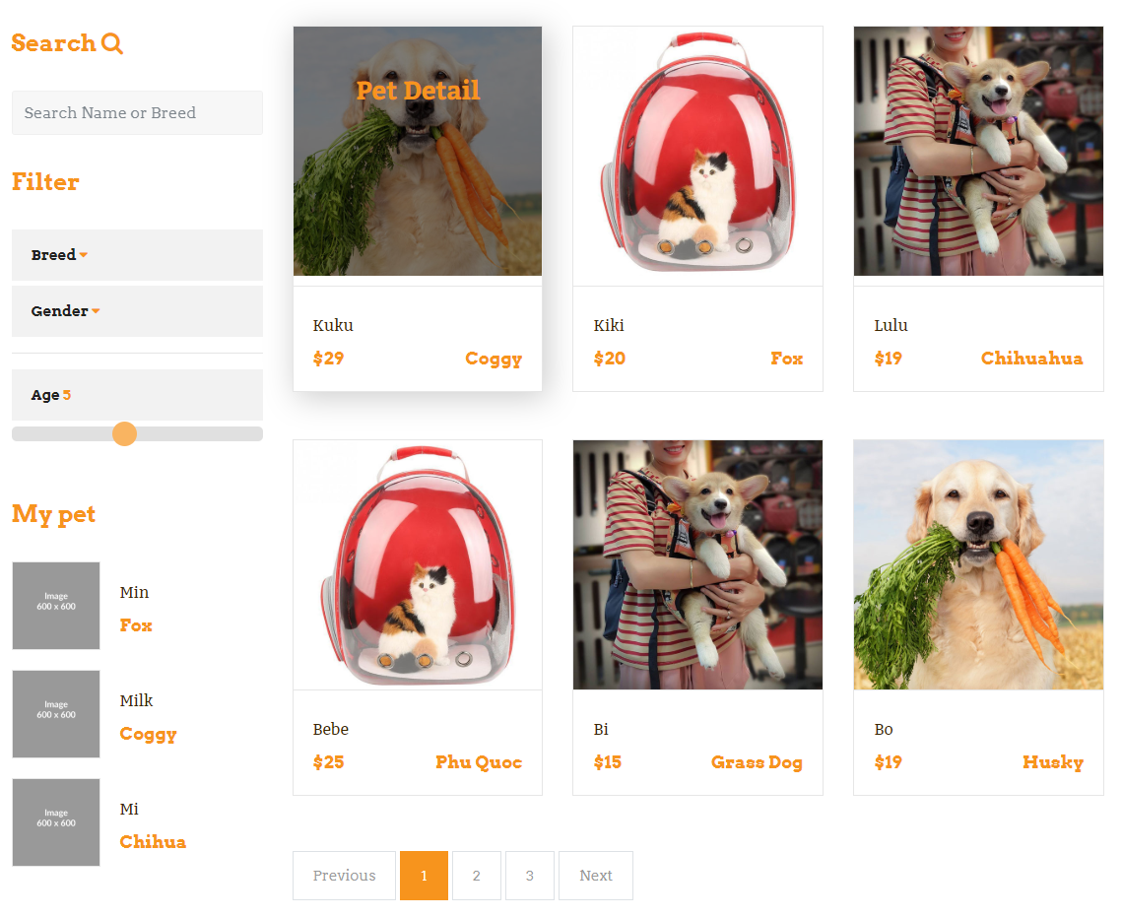

|  |  |
| --- | --- |
| Description | Show list of Pet list, filter (breed, gender or age) and my pet, search (name, breed) |
| Connect From | Home |
| Connect To | Pet detail |
| Validation | N/A |
| Initial Values | Name, photo, price, … |
| Events | - When click on pet’s photo, redirect to pet detail |

* + 1. ***Pet detail***

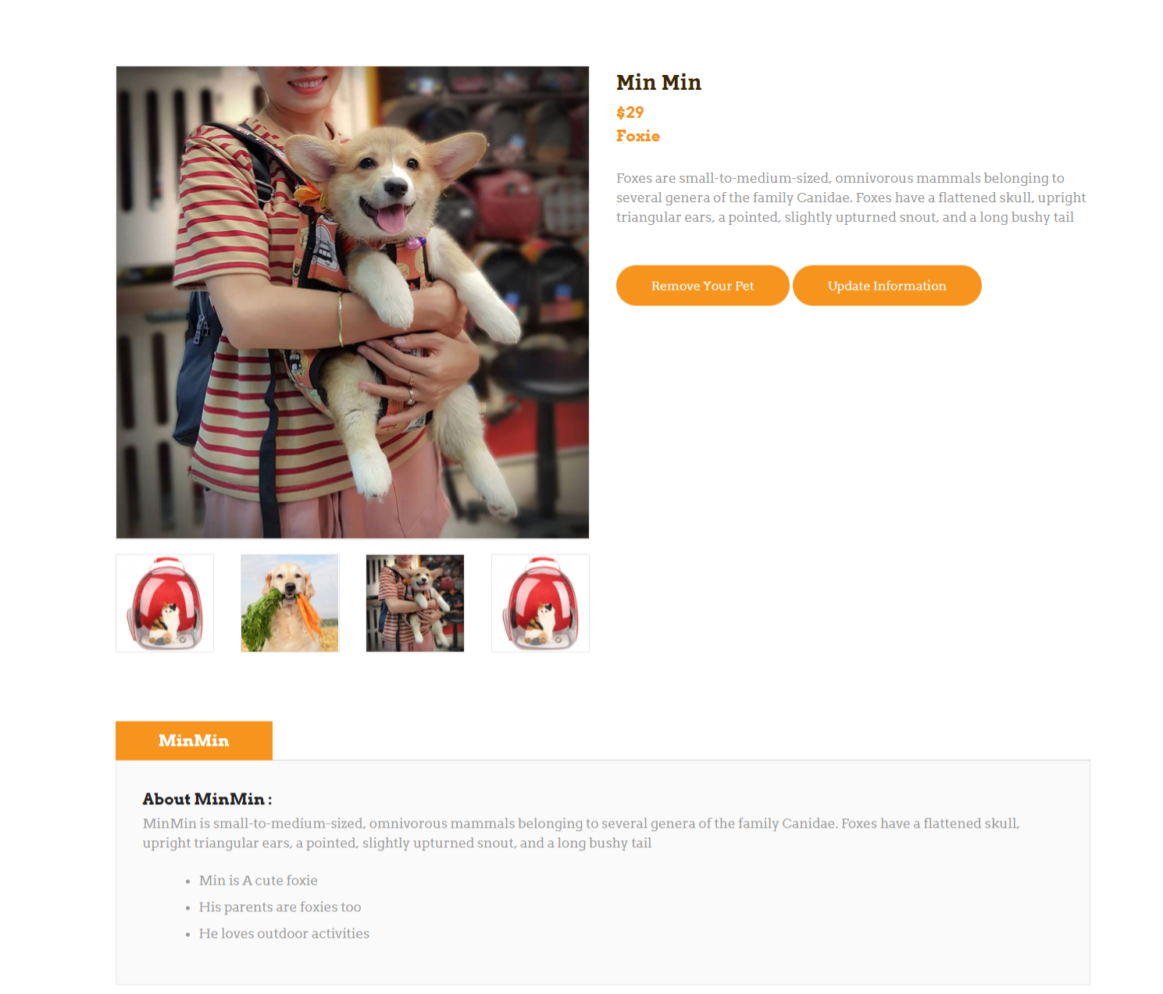

|  |  |
| --- | --- |
| Description | Show Pet’s detail |
| Connect From | Home, Pet page |
| Connect To | Update information, remove your pet |
| Validation | N/A |
| Initial Values | Product’s detail: name, price, images, description |
| Events | - When click button “Buy now”🡪 product’s added to cart |

* + 1. ***Pet Add***

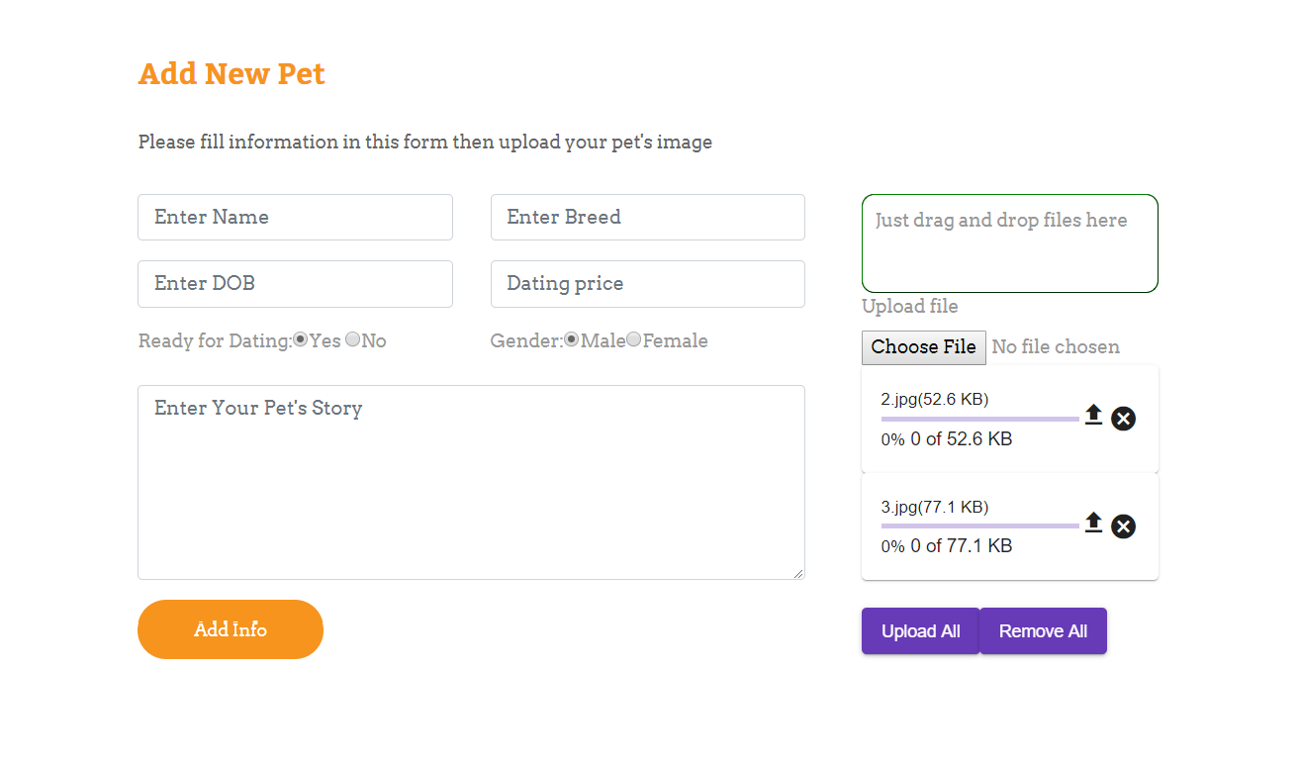

|  |  |
| --- | --- |
| Description | Insert new pet |
| Connect From | Pet list |
| Connect To | Pet list page |
| Validation | - Not Blank: all fields - category name is unique  - name: varchar(50);  - breed: varchar(20);  - price >0, int |
| Initial Values | N/A |
| Events | - when click "Add info" button, save new Pet to database and go to pet-list page - when click "Remove All" button, reset all fields to blank |

* + 1. ***Pet Update***

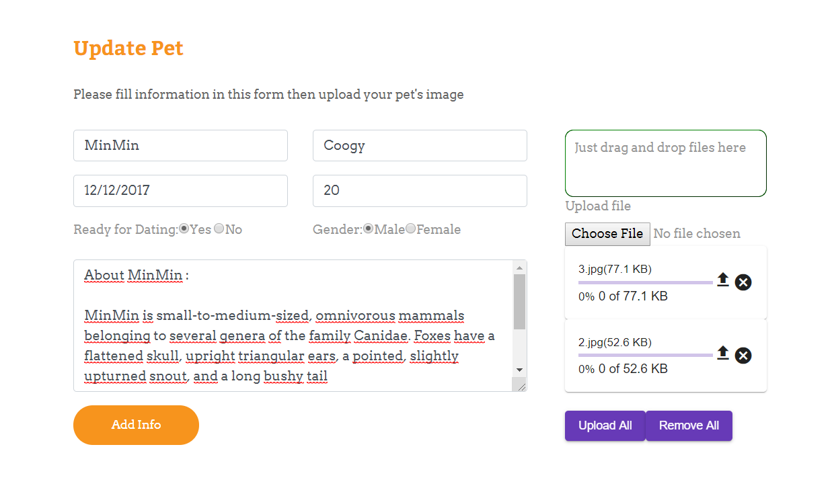

|  |  |
| --- | --- |
| Description | Update Pet |
| Connect From | Pet detail page |
| Connect To | Pet-detail page |
| Validation | - Not Blank: all fields - category name is unique  - name: varchar(50);  - breed: varchar(20);  - price >0, int |
| Initial Values | pet parent list |
| Events | - when click "upload all" button, update pet to database and go to pet-dateil page - when click "Remove All" button, reset all fields to blank |

* + 1. ***Gallery***

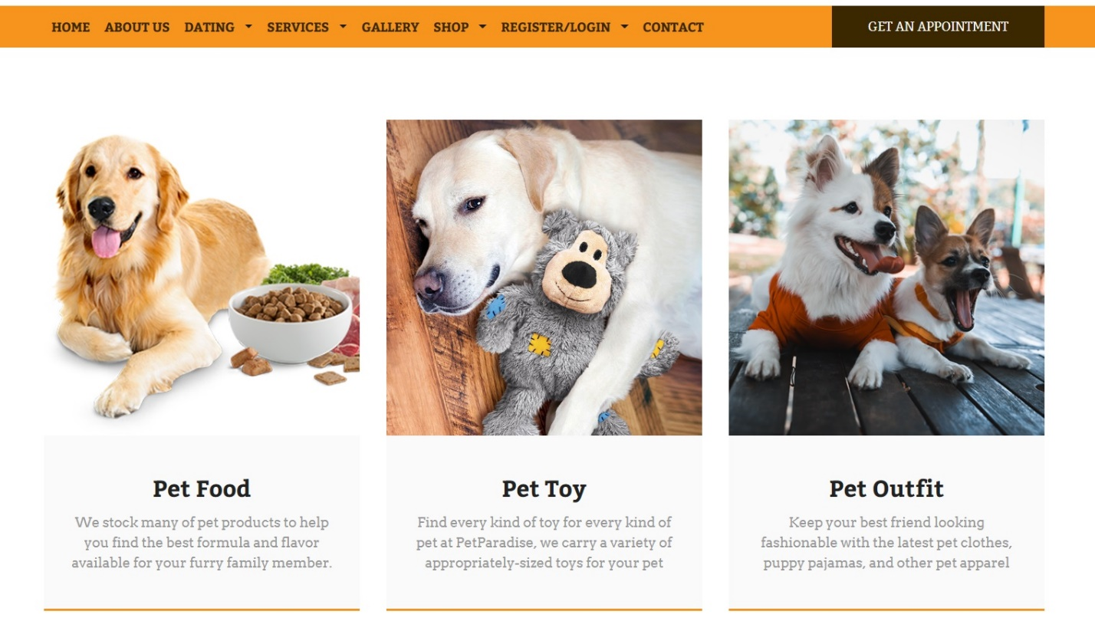

|  |  |
| --- | --- |
| Description | All galleries will show up |
| Connect From | Home |
| Connect To | Shop |
| Validation | N/A |
| Initial Values | N/A |
| Events | - When click Gallery’s name or Gallery’s photo 🡪 products of that gallery will show up |

* + 1. ***Product***

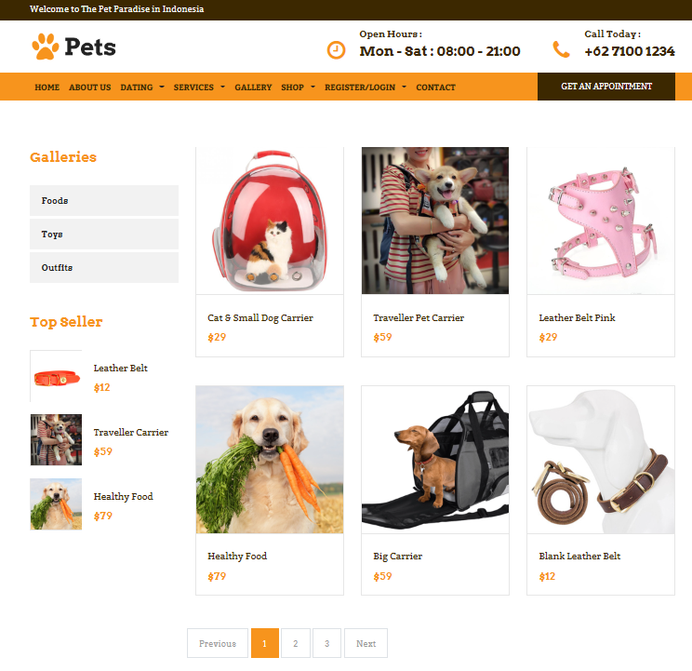

|  |  |
| --- | --- |
| Description | Show list of products, galleries and top sellers |
| Connect From | Home, category |
| Connect To | Product detail, Top seller |
| Validation | N/A |
| Initial Values | List of products following given criteria (category, images, price, description) |
| Events | - When click on product, redirect to product detail  - When click on top seller product, redirect to product detail  - When click on gallery item, redirect to gallery detail |

* + 1. ***Product details***

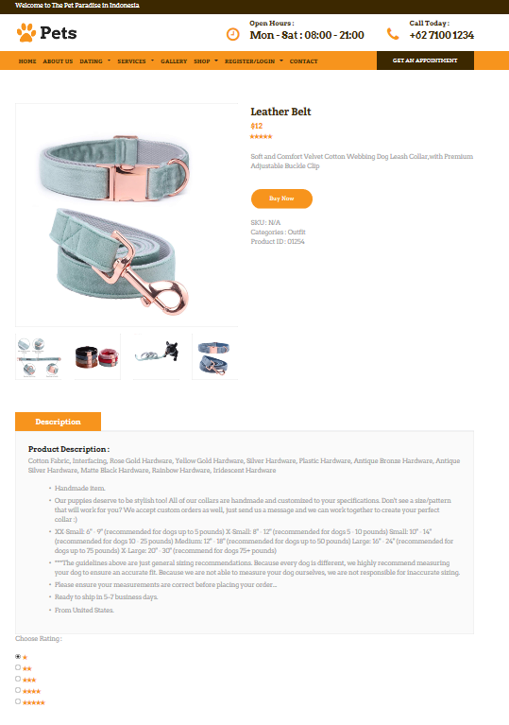***­***

|  |  |
| --- | --- |
| Description | Show product’s detail |
| Connect From | Home, product page, cart |
| Connect To | Cart |
| Validation | N/A |
| Initial Values | Product’s detail: name, price, images, description |
| Events | - When click button “Buy now”🡪 product’s added to cart |

* + 1. ***Popular product (top seller)***

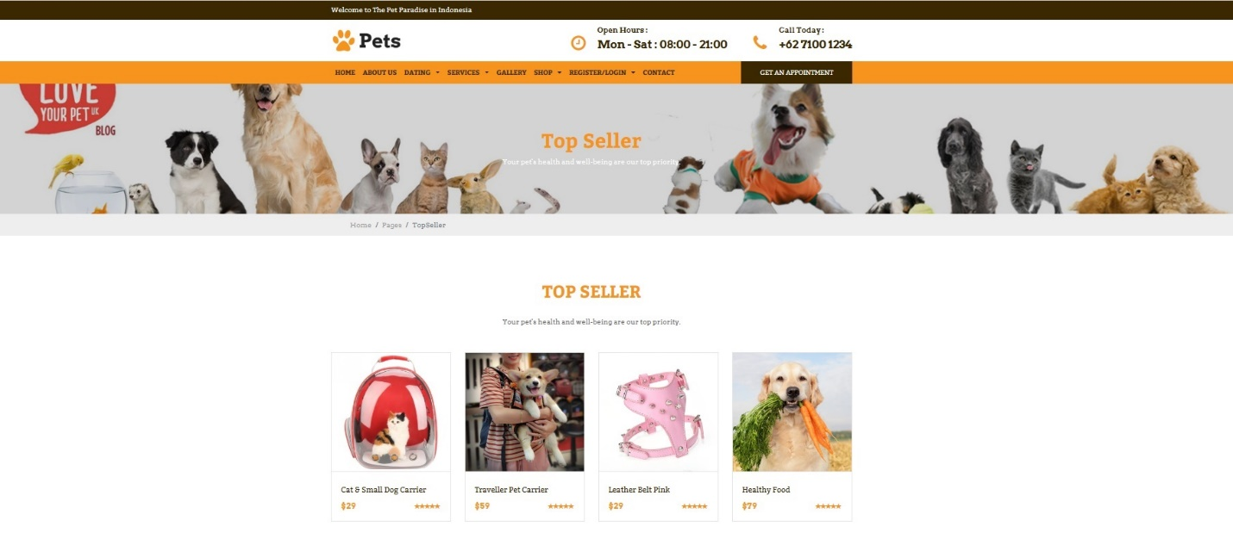

|  |  |
| --- | --- |
| Description | Show popular products (top seller) |
| Connect From | Shop page |
| Connect To | Product’s detail |
| Validation | N/a |
| Initial Values | N/A |
| Events | - When click on product, redirect to product detail |

* + 1. ***Search and filter product***

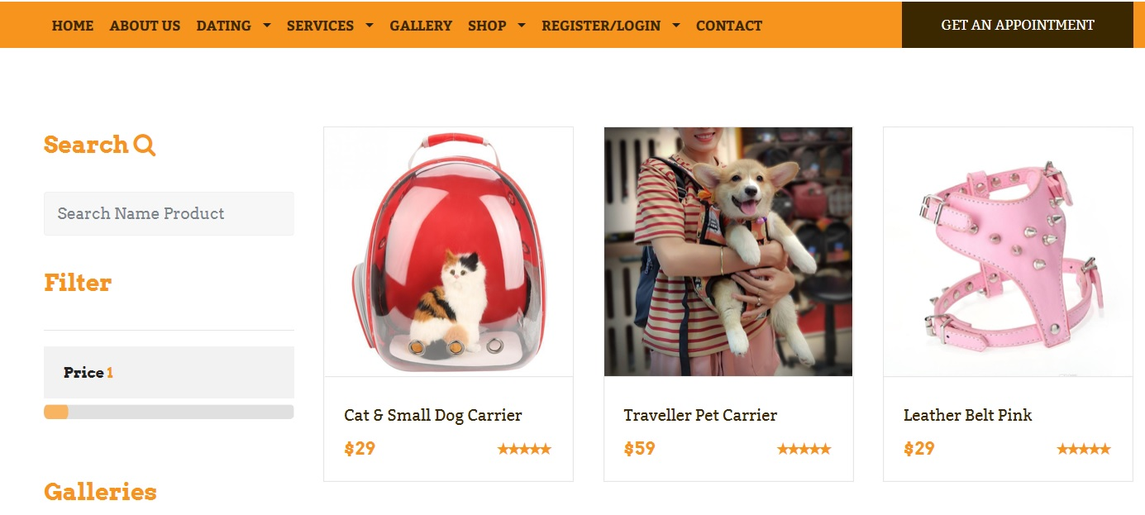

* + 1. ***About us***

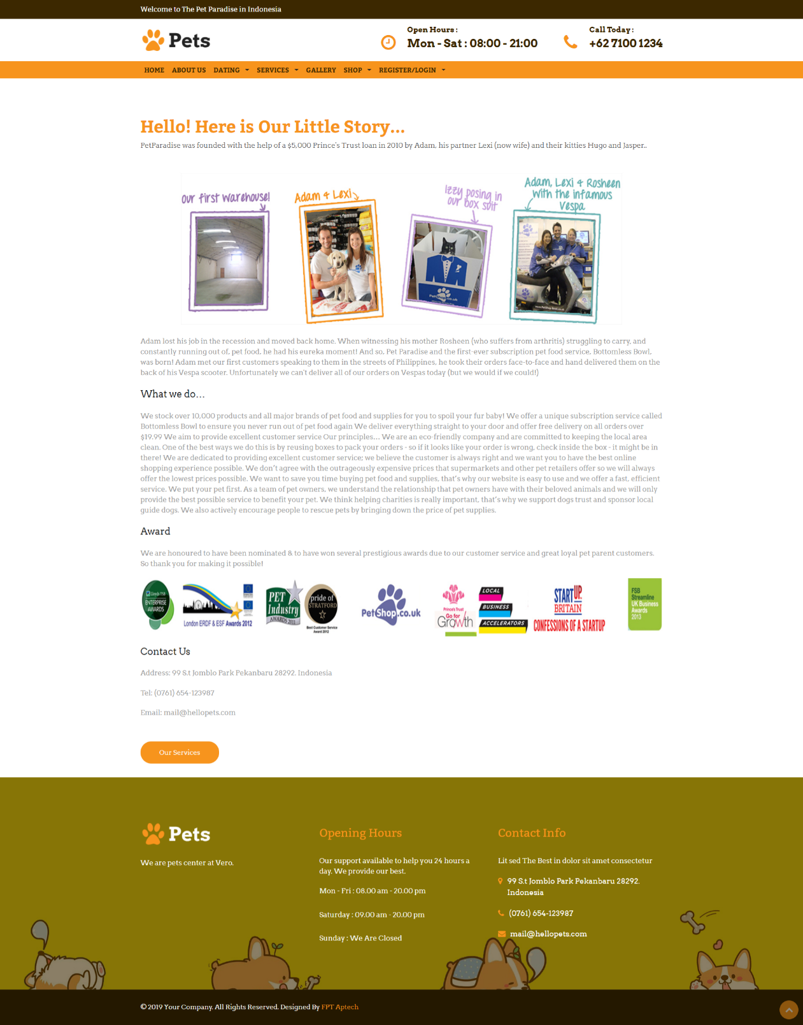

|  |  |
| --- | --- |
| Description | About-Us page |
| Connect From | N/A |
| Connect To | N/A |
| Validation | N/A |
| Initial Values | N/A |
| Events | N/A |

* + 1. ***Cart page***

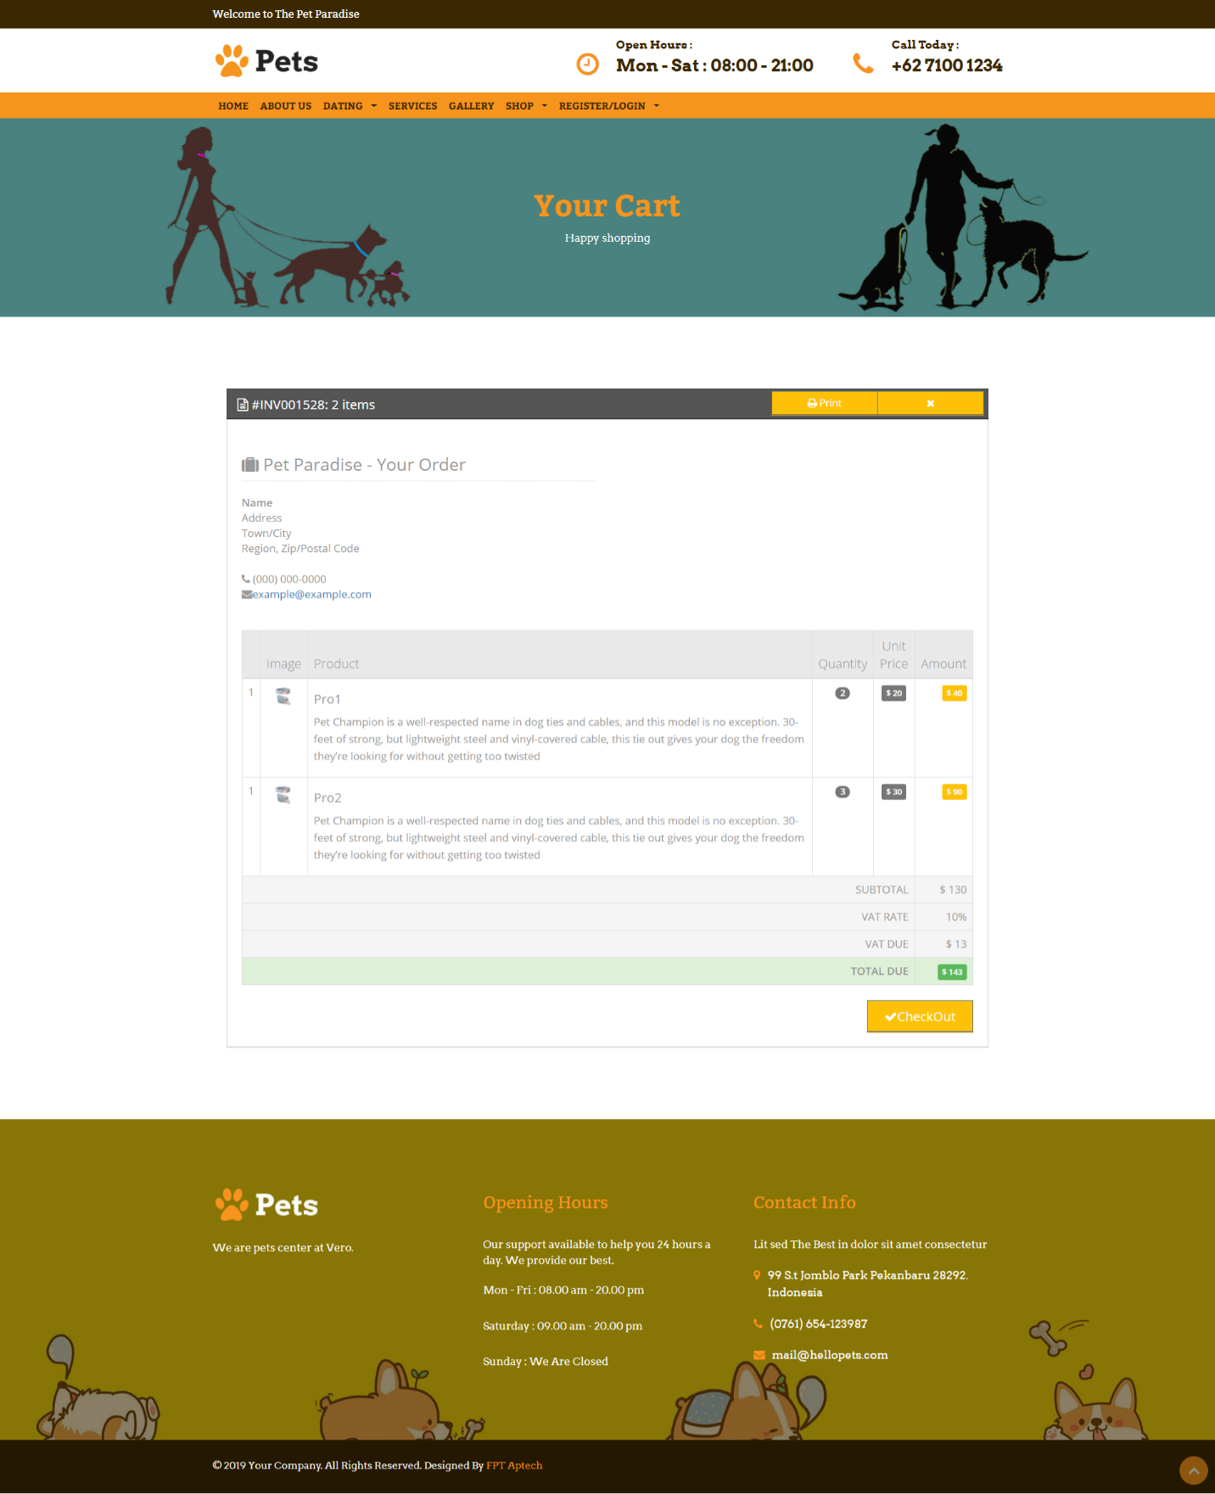

|  |  |
| --- | --- |
| Description | Cart page |
| Connect From | Top Navigation |
| Connect To | Place Order page |
| Validation | Cart is not empty |
| Initial Values | List of products in cart |
| Events | - If customer is logged in, they can buy products  - When click “Checkout” button, redirect to payment page |

* + 1. ***Appointment form***

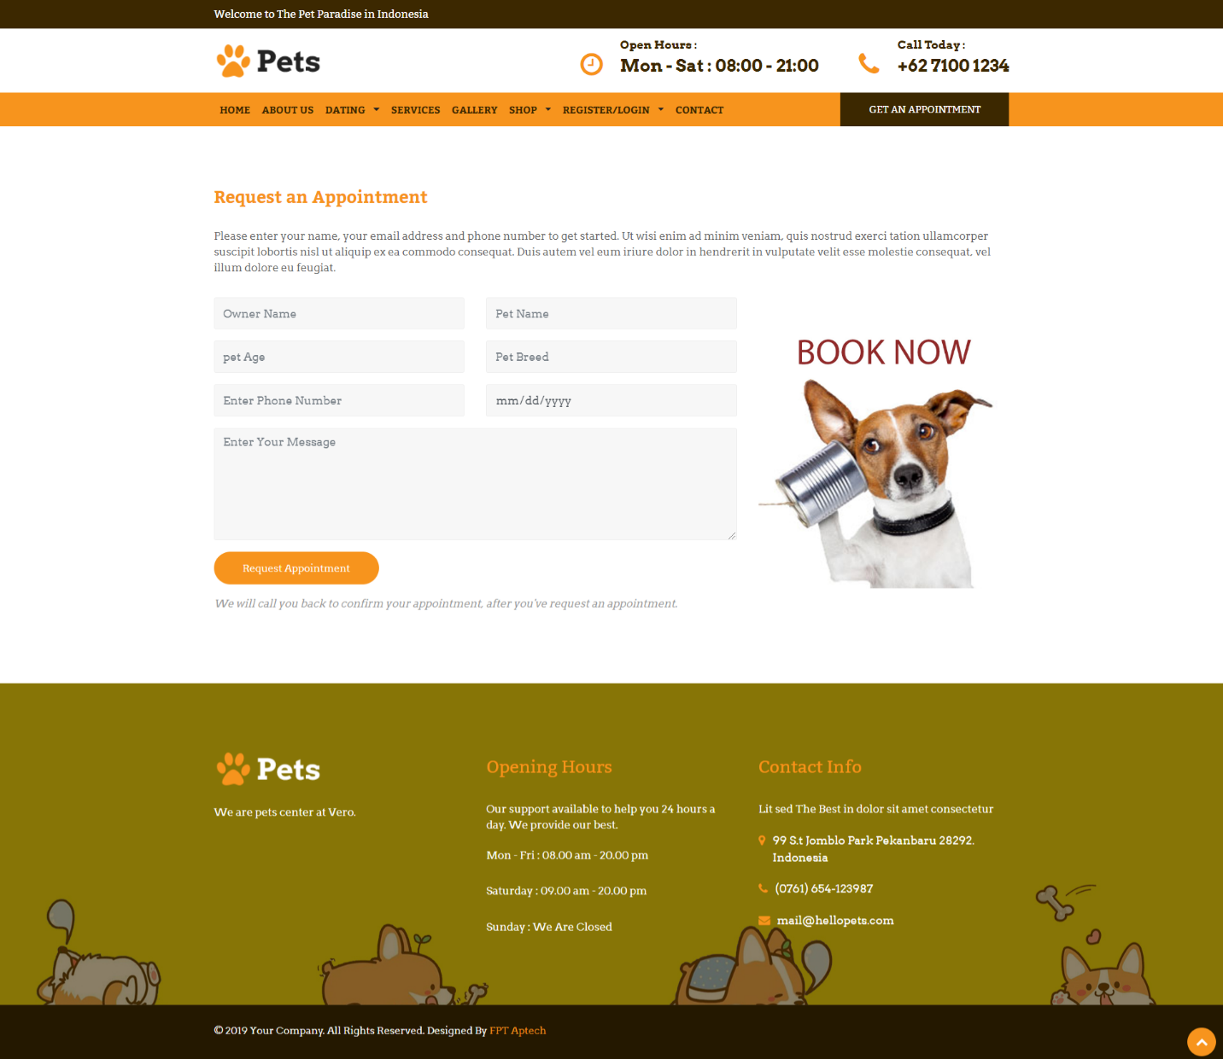

|  |  |
| --- | --- |
| Description | Appointment form page |
| Connect From | Service detail, menu |
| Connect To | N/a |
| Validation | All fields is not empty |
| Initial Values | N/a |
| Events | - If customer is logged in, they can book appointment  - When click “Request appointment” button, will send the request to admin |

* + 1. ***Service***

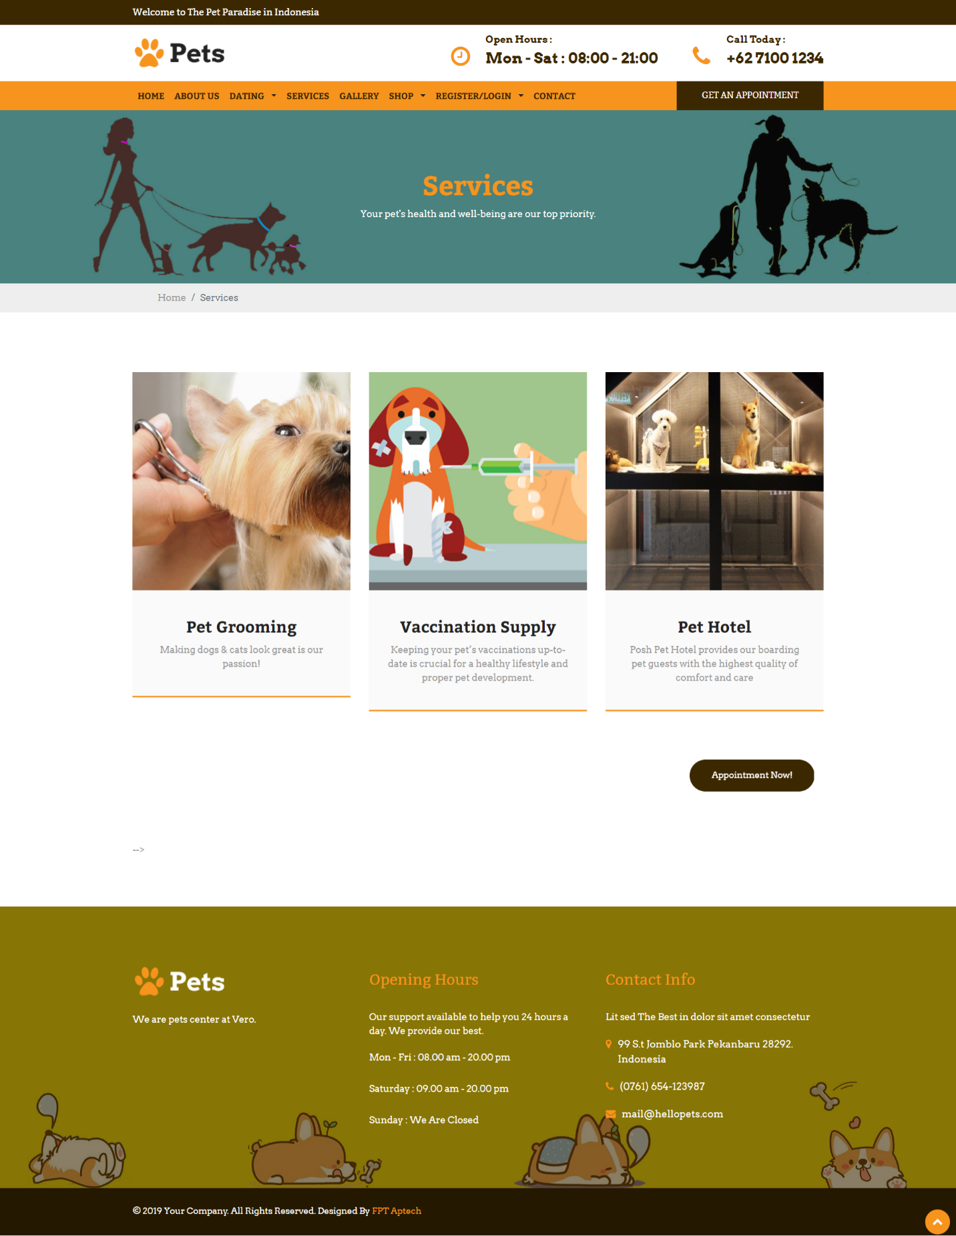

|  |  |
| --- | --- |
| Description | Show list of service |
| Connect From | Home Service menu |
| Connect To | Service detail |
| Validation | N/A |
| Initial Values | List of Service following |
| Events | - When click on Service, redirect to Service details |

* + 1. ***Service Detail***

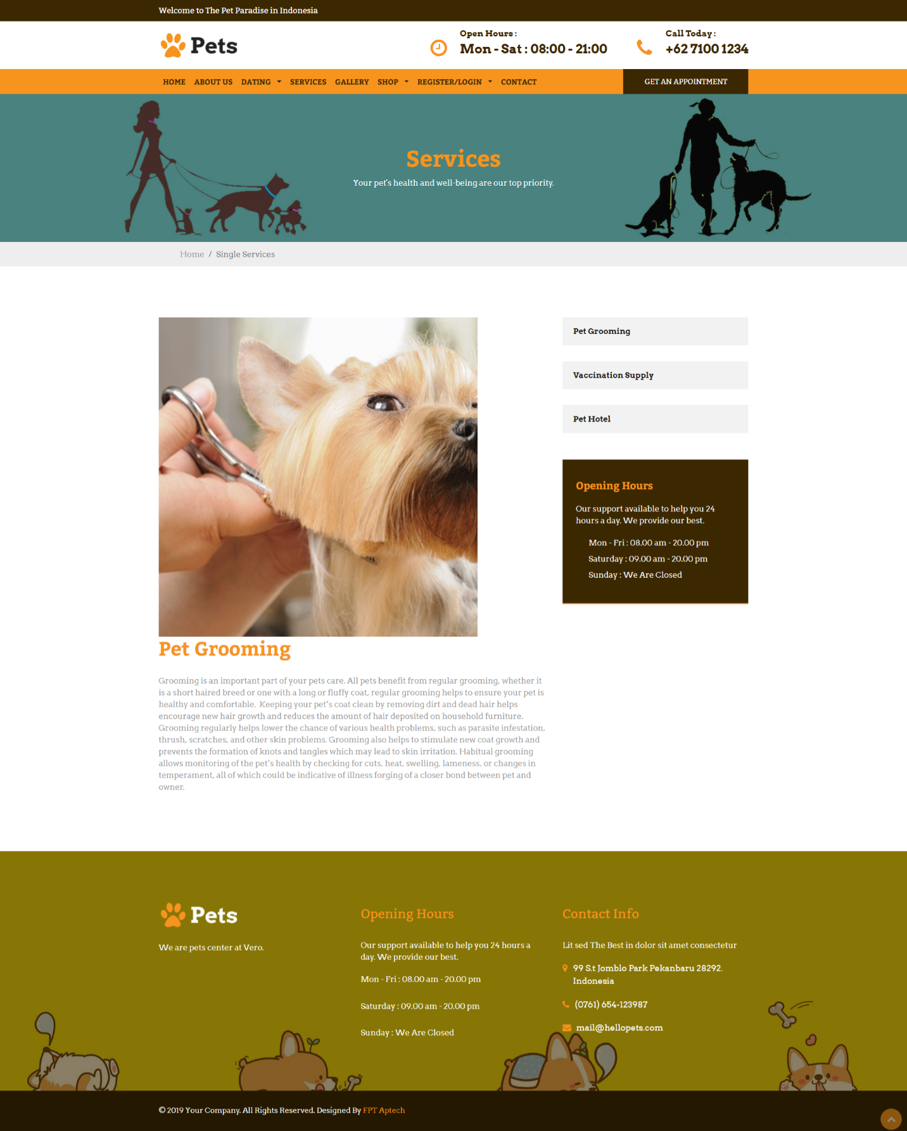

|  |  |
| --- | --- |
| Description | Show service’s detail |
| Connect From | Home, service’s page, |
| Connect To | Get Appointment page |
| Validation | N/A |
| Initial Values | information of Service following |
| Events | - When click button “Get Appointment”🡪 redirect to “Appointment form” page |

* + 1. ***sada***

1. **Admin’s Site**
   * 1. ***Admin Login***

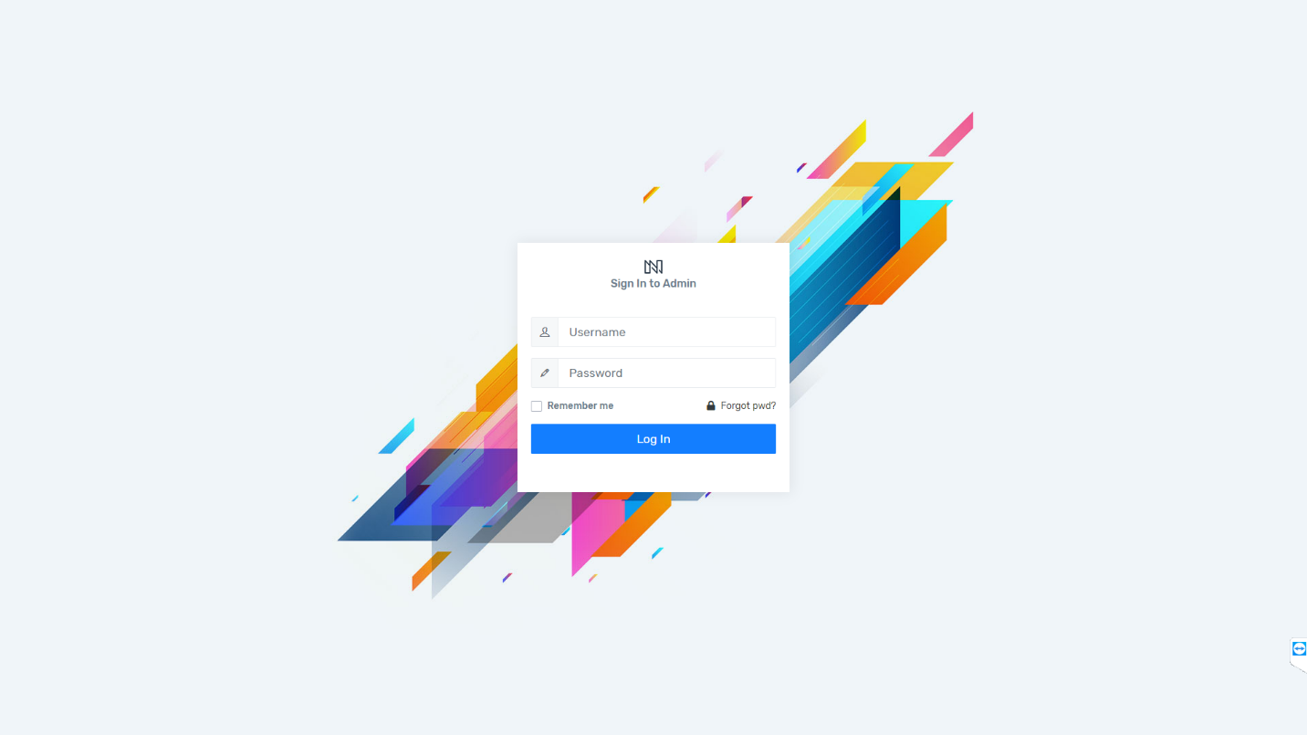

* + 1. ***Admin’s Dashboard***

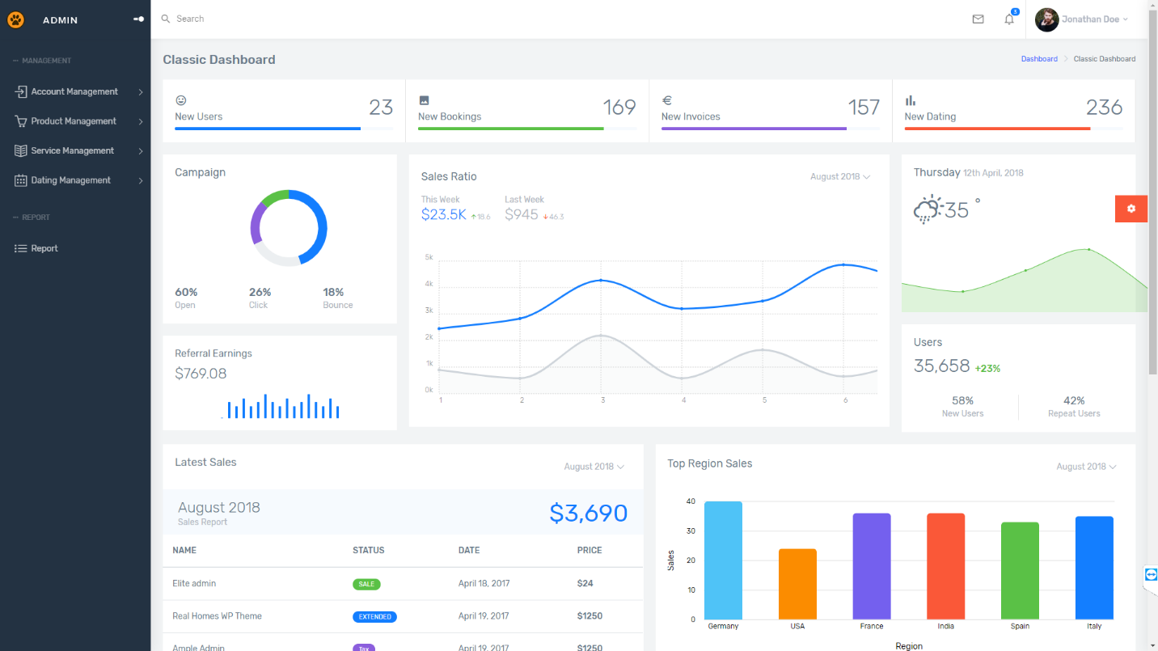

* + 1. ***Customer list***

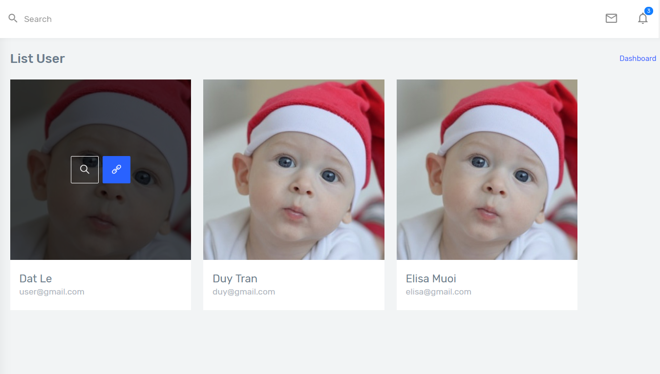

|  |  |
| --- | --- |
| Description | Customer’s list (profile) |
| Connect From | Home, Login page |
| Connect To | Customer’s dashboard |
| Validation | Must log in to view |
| Initial Values | N/A |
| Events | - When click tab “photo”, view customer’s profile |

* + 1. ***Customer’s dashboard***

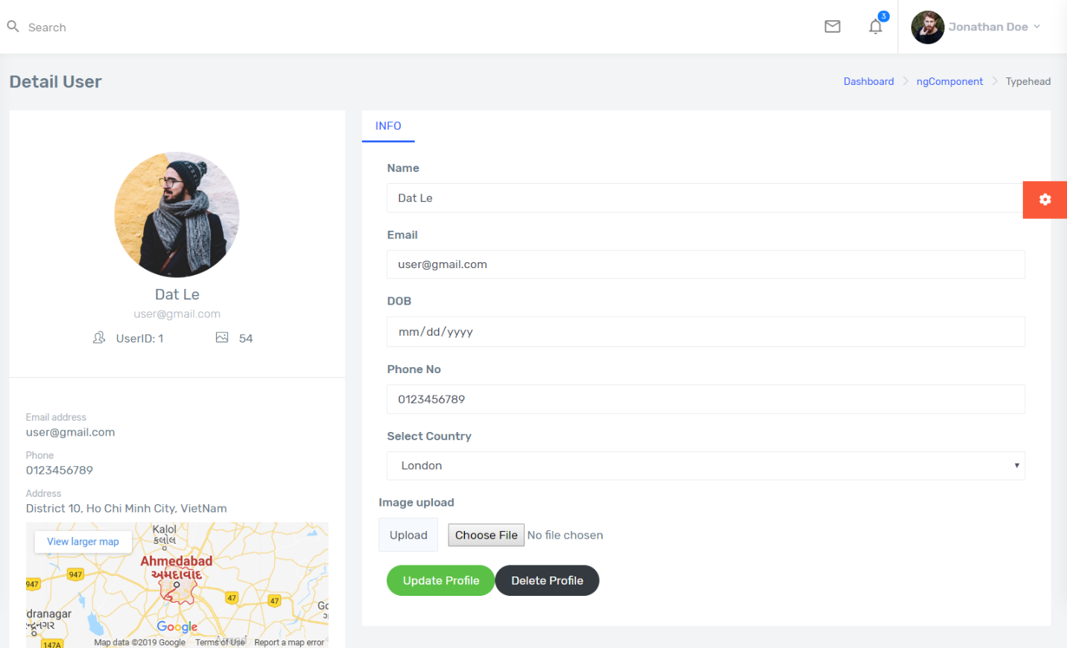

|  |  |
| --- | --- |
| Description | Customer’s dashboard (profile) |
| Connect From | Home, Login page |
| Connect To | Update profile, delete profile |
| Validation | - All fields cannot be blank  - Name is no more than 50 characters  - Email: email type  - phone: number |
| Initial Values | Name, email, DOB, Telephone, country, image.. |
| Events | - When click tab “Update Profile”, view customer’s profile  - When click tab “delete profile”, view profile list |

* + 1. ***Category list***

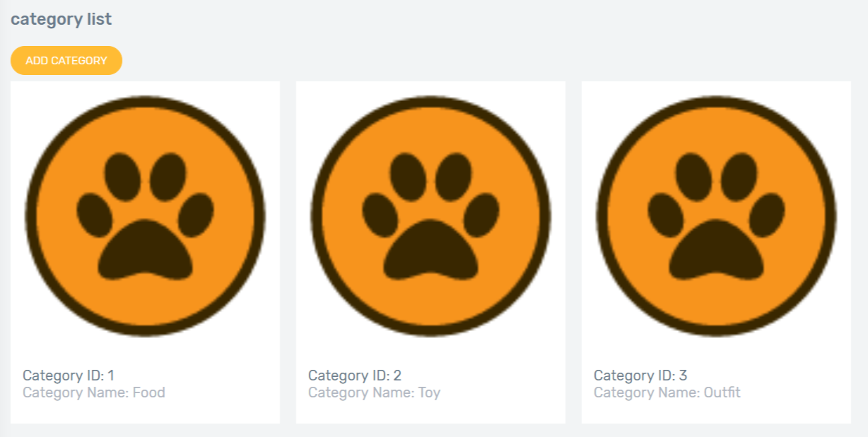

* + 1. ***Category add***

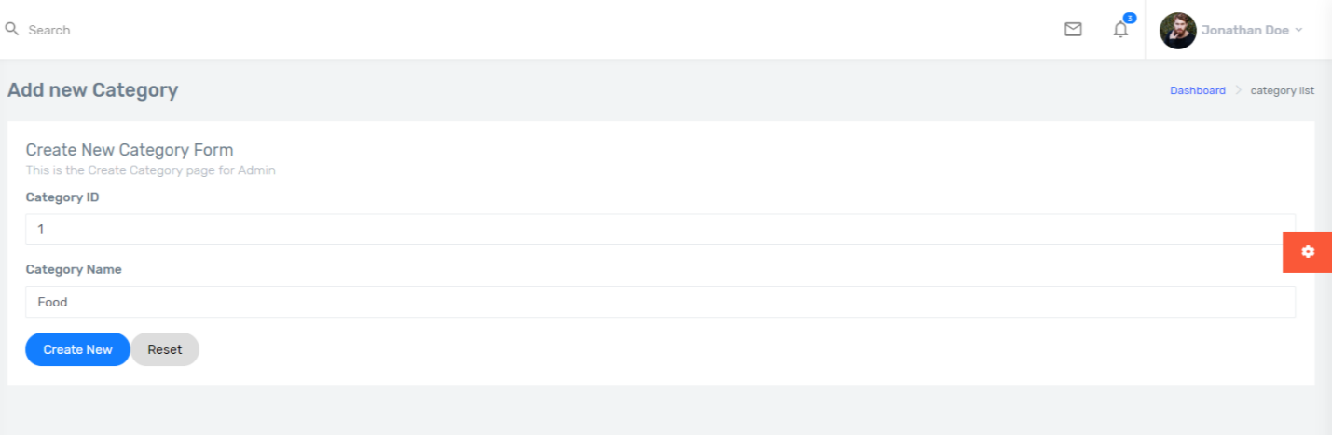

* + 1. ***Category detail***

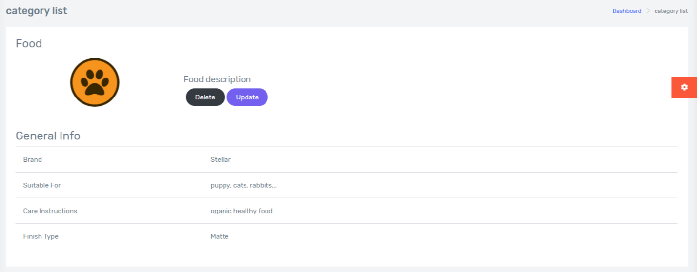

* + 1. ***Category update***

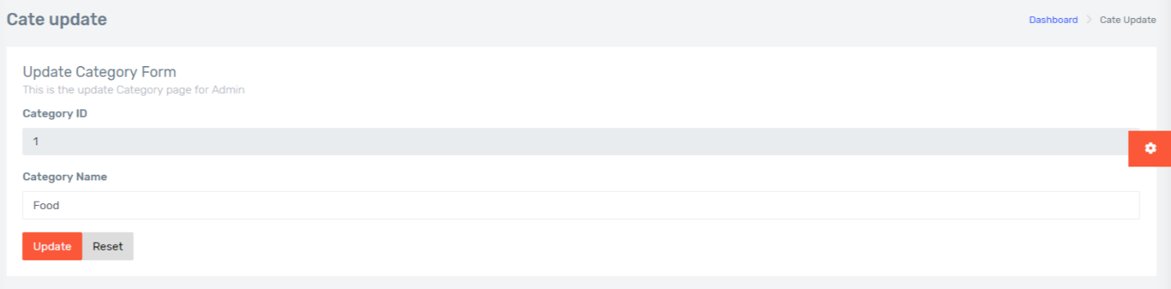

* + 1. ***Category delete***



* + 1. ***Product list***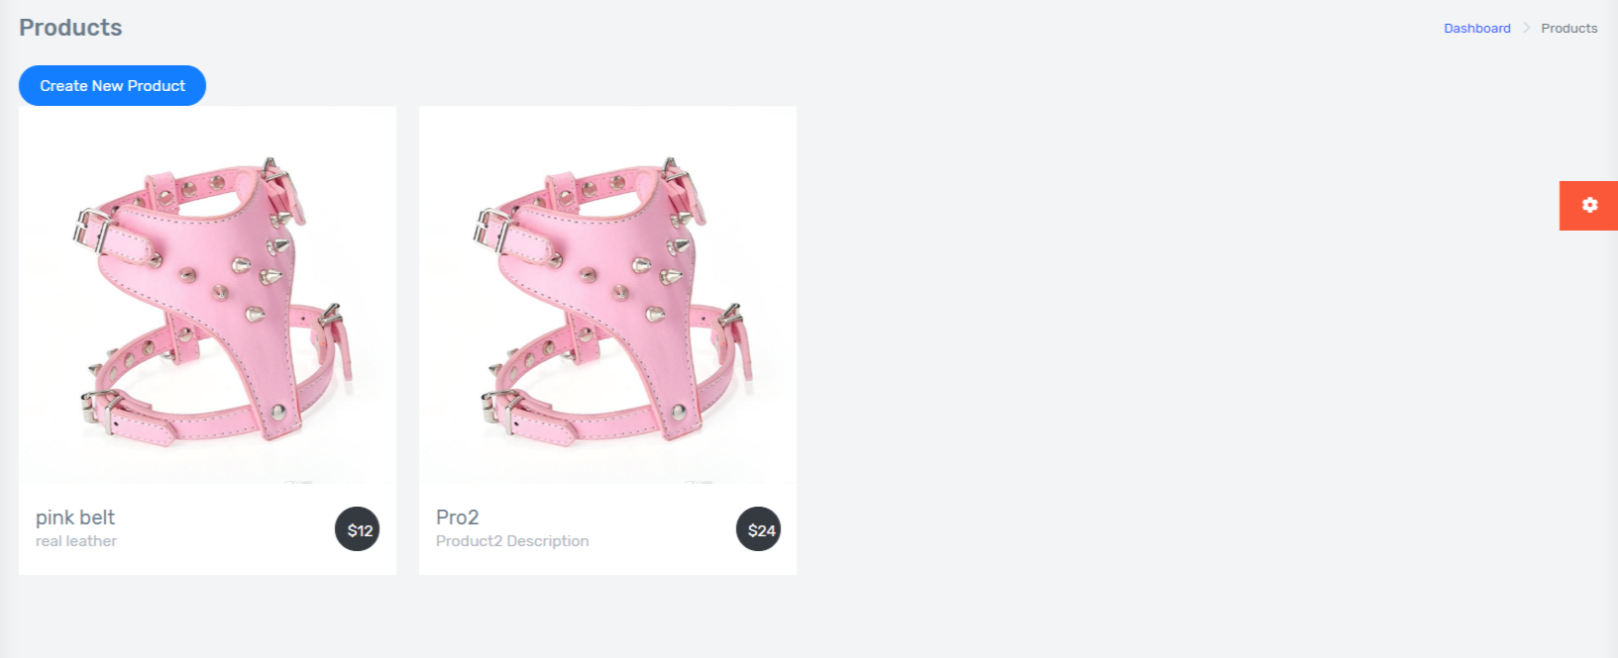
    2. ***Product details***

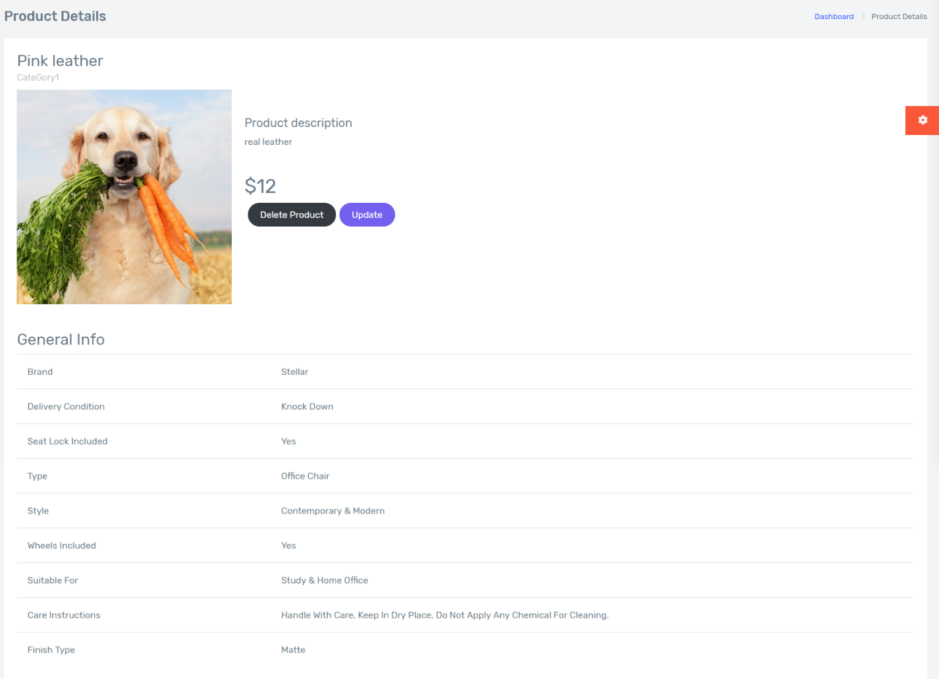

* + 1. ***Product add***

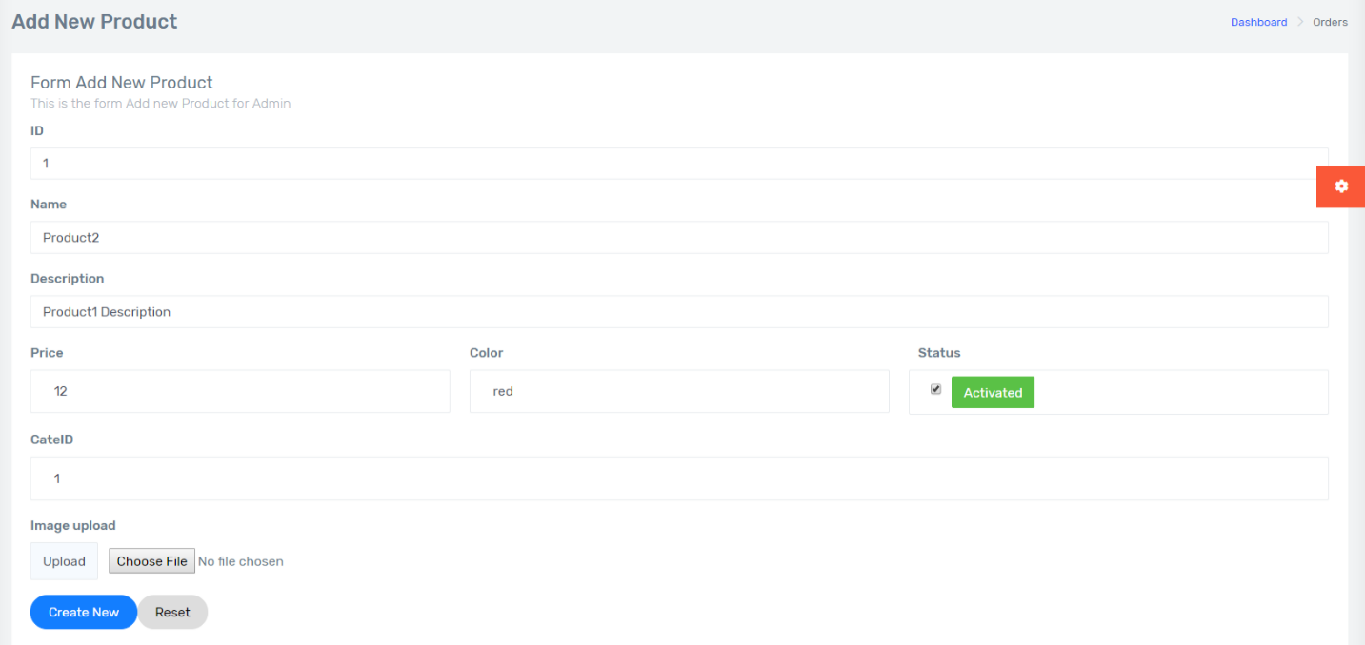

* + 1. ***Product update***

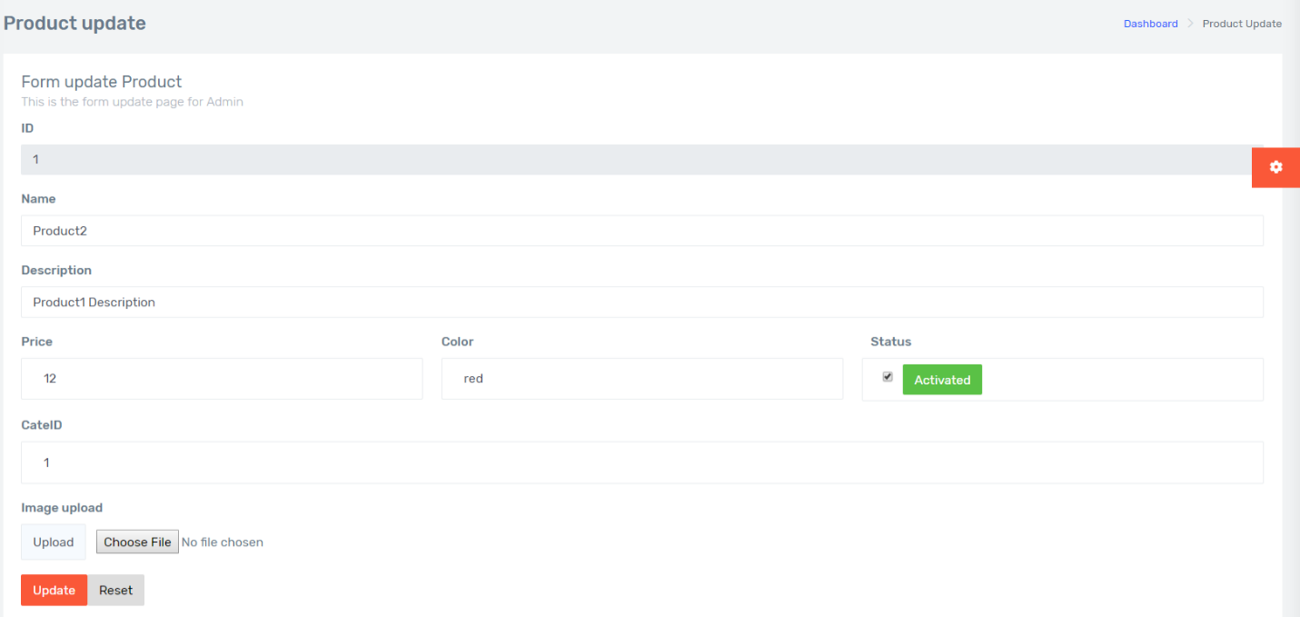

* + 1. ***Product delete***



* + 1. ***Service List***

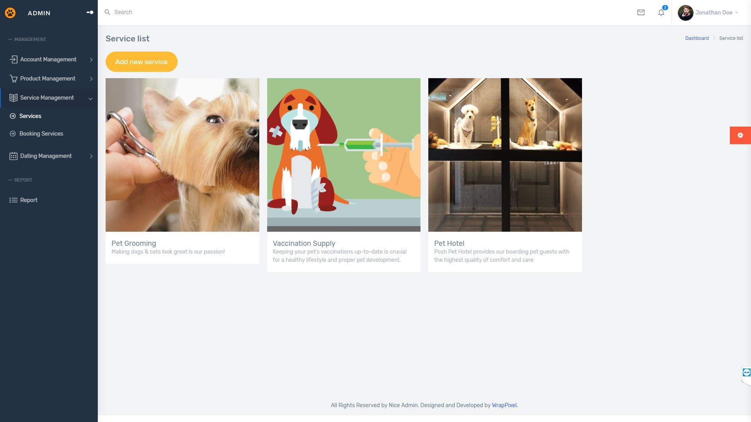

|  |  |
| --- | --- |
| Description | List all services |
| Connect From | Sidebar’s Service Manage tab |
| Connect To | Service Detail  Create new Service  Service Edit |
| Validation | N/A |
| Initial Values | Service List |
| Events | - Click on button "Add new service": Go to Add new service page.  -Click on icon “Detail”: Go to Service detail page  -Click on icon “Edit”: Go to Service edit page |

* + 1. ***Service Add***

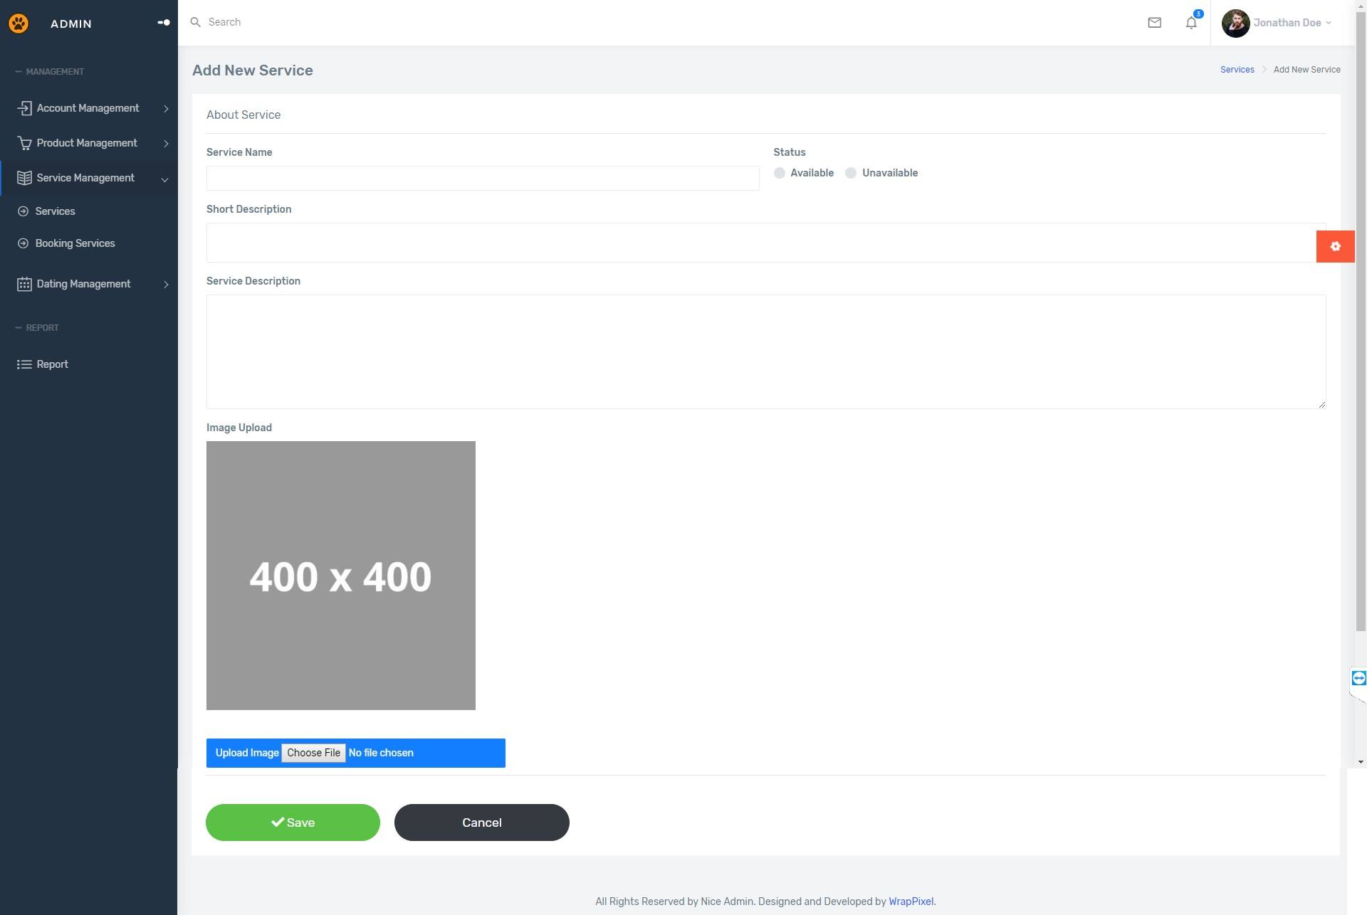

|  |  |
| --- | --- |
| Description | Add a new service |
| Connect From | Service List page |
| Connect To | N/A |
| Validation | -All fields: not blank - Name: must be unique |
| Initial Values | N/A |
| Events | - Click on button "Save": check all field validation. Add a new service to database.  -Click on button “Cancel”: reset all field. |

* + 1. ***Service Update***

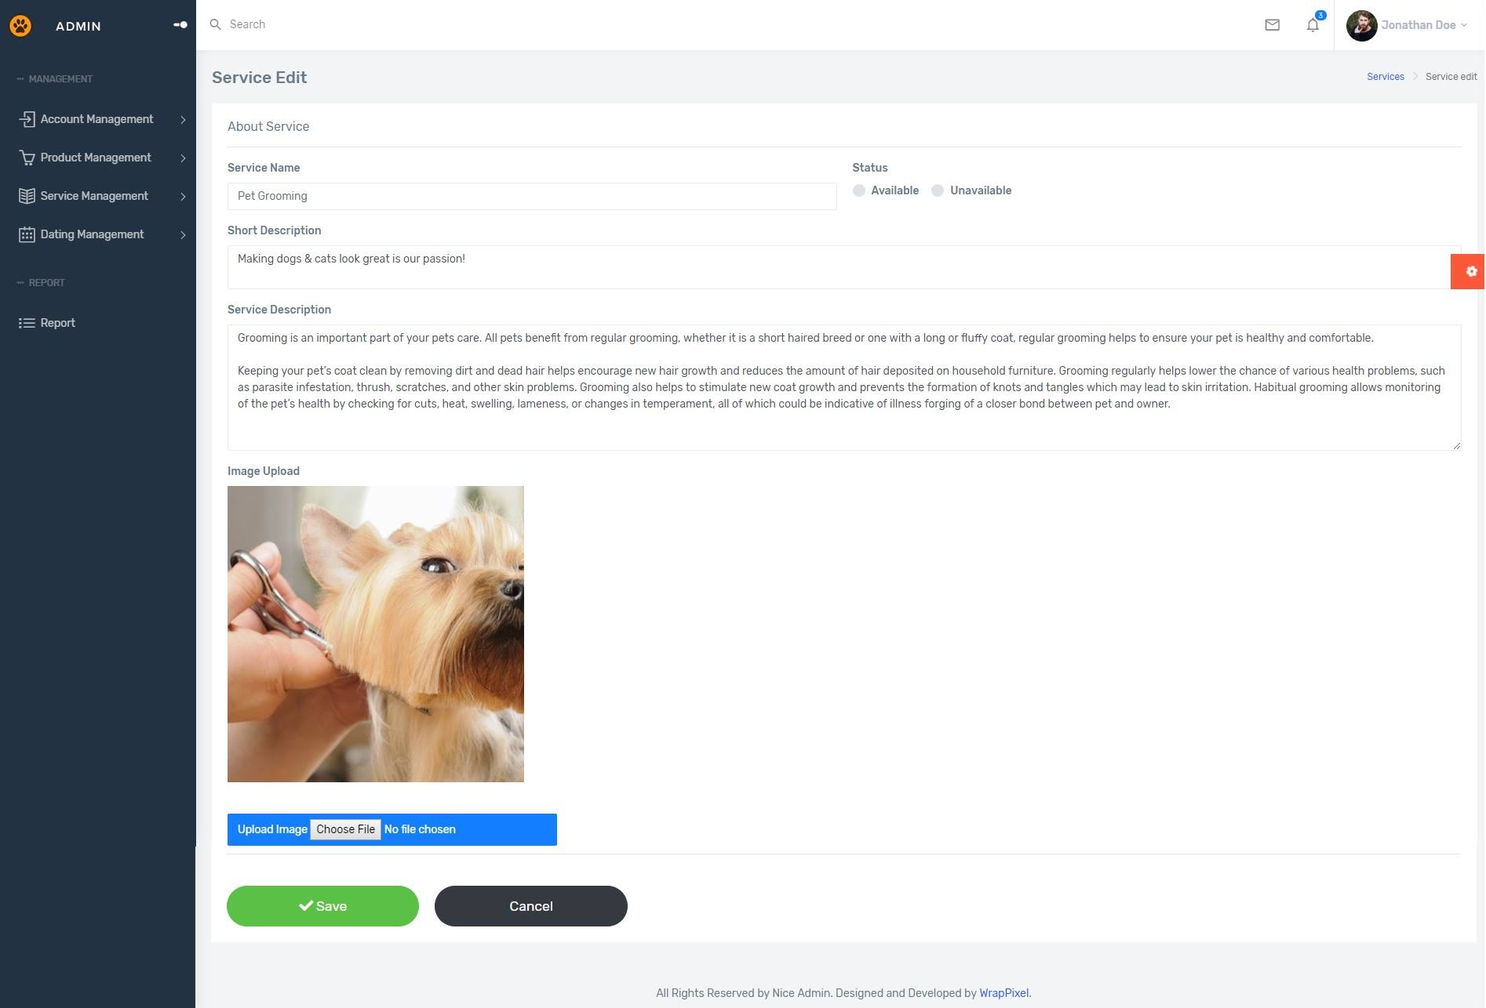

|  |  |
| --- | --- |
| Description | Update Service |
| Connect From | Service List; Service Detail |
| Connect To | N/A |
| Validation | All fields: not blank - Name: must be unique |
| Initial Values | Product Detail |
| Events | - Click on button "Save": check all field validation. Update detail to database.  -Click on button “Cancel”: redirect to Service detail page. |

* + 1. ***Service Delete***

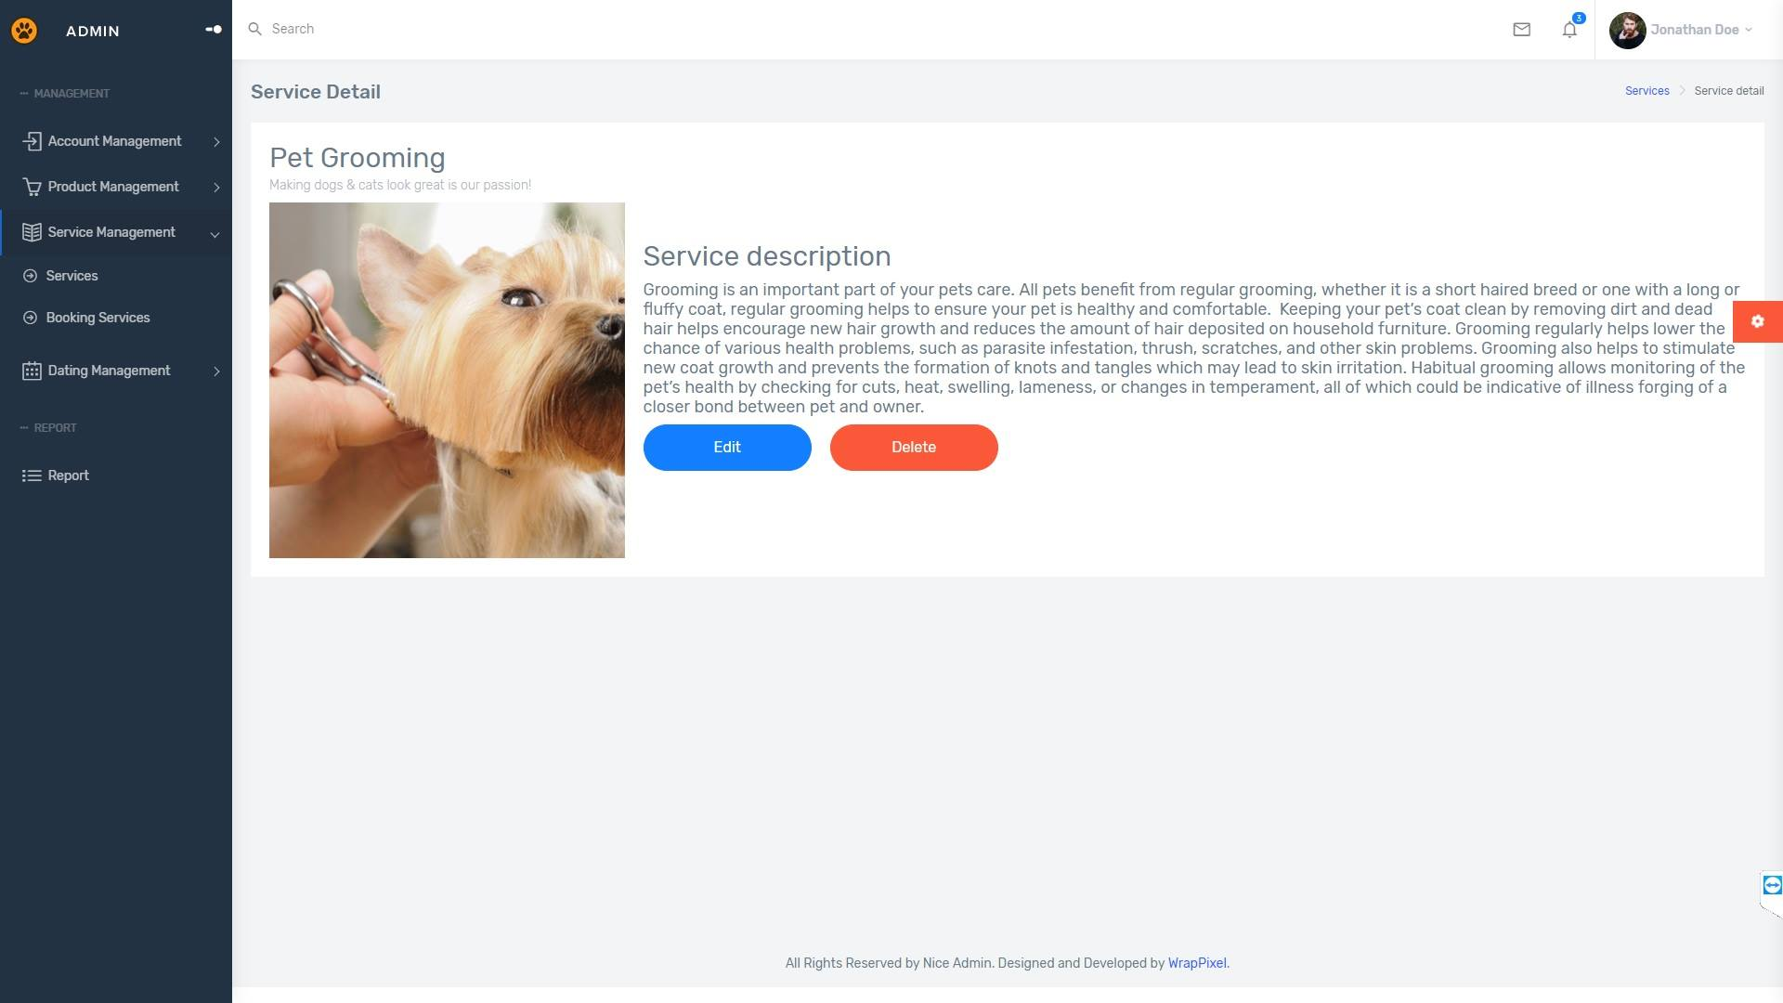

|  |  |
| --- | --- |
| Description | Delete Service |
| Connect From | Service Detail |
| Connect To | N/A |
| Validation | N/A |
| Initial Values | Product Detail |
| Events | - Click on button "Delete": confirm again. Delete service from database. |

* + 1. ***List Pet***

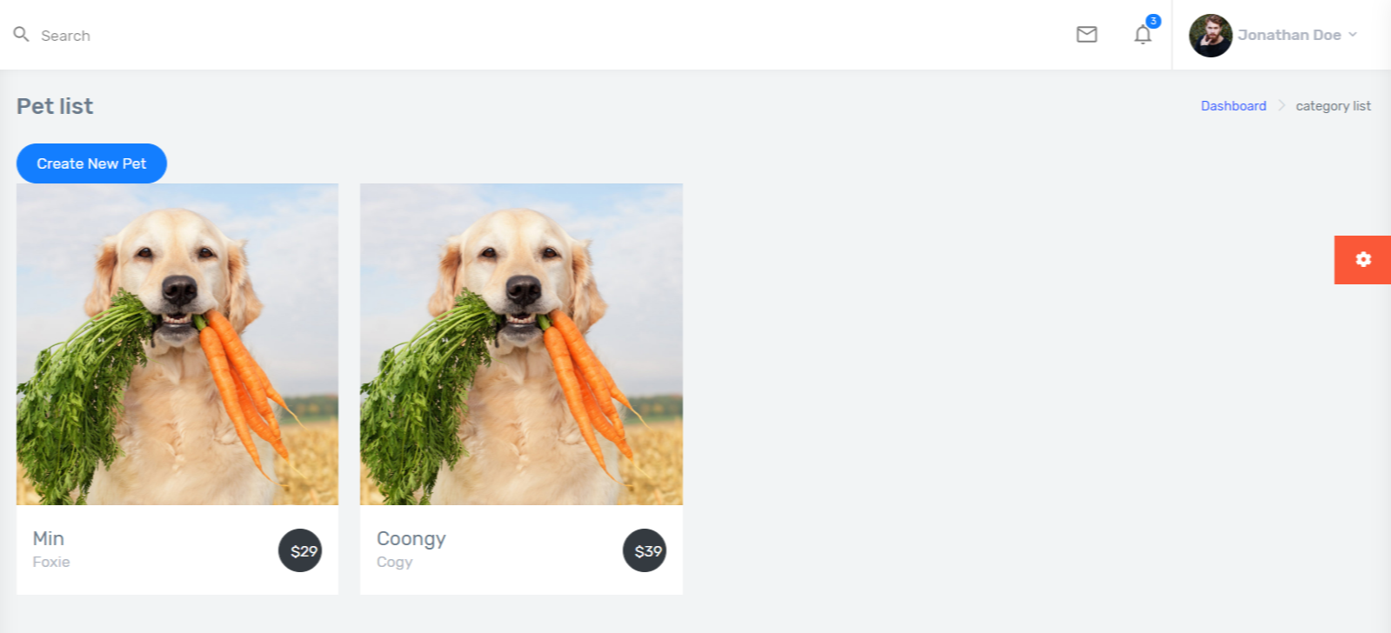

* + 1. ***Pet detail***

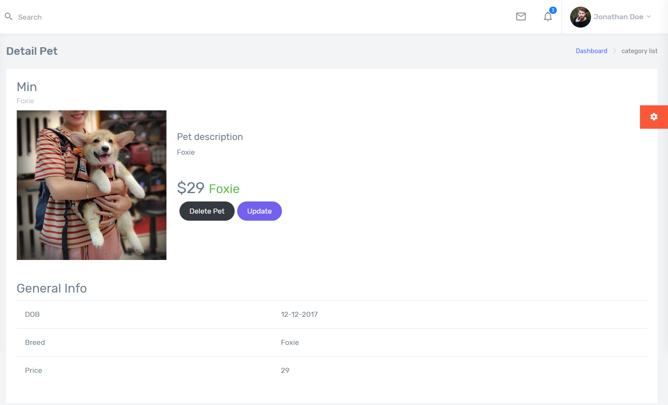

* + 1. ***Add Pet***

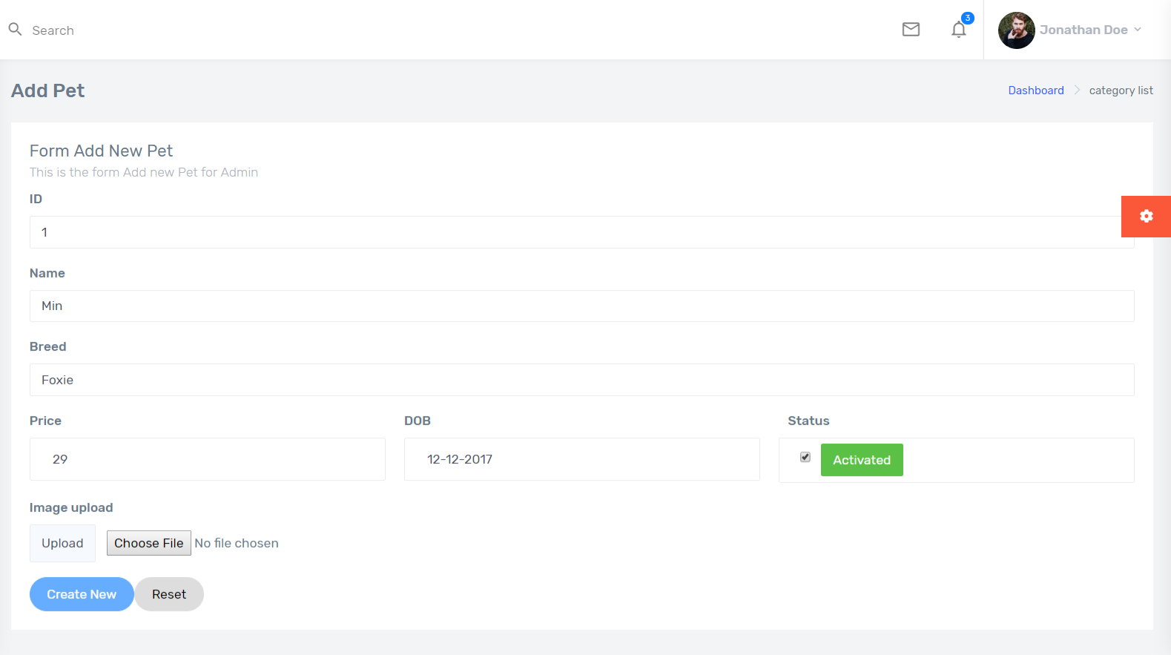

* + 1. ***Update Pet***

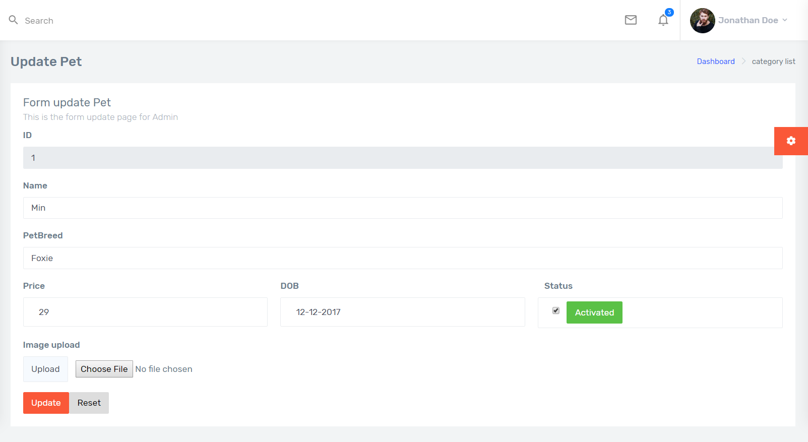

REVIEW 3 – TASK SHEET

|  |  |  |  |  |  |
| --- | --- | --- | --- | --- | --- |
| **No.** | **Contents** | **Member** | **Activity Plan** | **Preparation** | |
| **Start Date** | **Actual Days** | **Status** |
| 1 | Client’s site map | Tran Tan Duy | 10/04/2019 | 15 | Completed |
| 2 | Admin’s site map | Tran Tan Duy |
| **Client** | | |
| 1 | Homepage | Le Cong Dat |
| 2 | Register | Le Cong Dat |
| 3 | Update user | Le Cong Dat |
| 4 | Login | Le Cong Dat |
| 5 | About us | Le Cong Dat |
| 6 | Dating List | Le Cong Dat |
| 7 | Pet Dating | Le Cong Dat |
| 8 | Pet List | Le Cong Dat |
| 9 | Pet Detail | Le Cong Dat |
| 10 | Pet Add | Le Cong Dat |
| 11 | Pet Update | Le Cong Dat |
| 12 | Pet Delete | Le Cong Dat |
| 13 | Gallery | Tran Thi Tuyet Duyen |
| 14 | Product | Tran Thi Tuyet Duyen |
| 15 | Product Details | Tran Thi Tuyet Duyen |
| 16 | Top Seller | Tran Thi Tuyet Duyen |
| 17 | Search and Filter Product | Tran Thi Tuyet Duyen |
| 18 | Cart Page | Tran Thi Tuyet Duyen |
| 19 | Appointment Form | Tran Tan Duy |
| 20 | Services | Tran Tan Duy |
| 21 | Service detail | Tran Tan Duy |
| **Admin** | |  |
| 1 | Admin Login | Le Cong Dat |
| 2 | Admin’s Dashboard | Tran Tan Duy |
| 3 | Category list | Tran Thi Tuyet Duyen |
| 4 | Category add | Tran Thi Tuyet Duyen |
| 5 | Category details | Tran Thi Tuyet Duyen |
| 6 | Category update | Tran Thi Tuyet Duyen |
| 7 | Category delete | Tran Thi Tuyet Duyen |
| 8 | Product list | Tran Thi Tuyet Duyen |
| 9 | Product details | Tran Thi Tuyet Duyen |
| 10 | Product add | Tran Thi Tuyet Duyen |
| 11 | Product update | Tran Thi Tuyet Duyen |
| 12 | Product delete | Tran Thi Tuyet Duyen |
| 13 | Service List | Tran Tan Duy |
| 14 | Service add | Tran Tan Duy |
| 15 | Service update | Tran Tan Duy |
| 16 | Service delete | Tran Tan Duy |
| 17 | List Pet | Le Cong Dat |
| 18 | Pet detail | Le Cong Dat |
| 19 | Pet Add | Le Cong Dat |
| 20 | Delete Pet | Le Cong Dat |
| 21 | Update Pet | Le Cong Dat |

Plan prepared by: Group 2 May 2st, 2019  
 **Group Leader Faculty**

**Tran Thi Tuyet Duyen Mr. Cat Nghiem Hieu Tuan**